
TRAUMA &
HOSPITAL
- GHANA
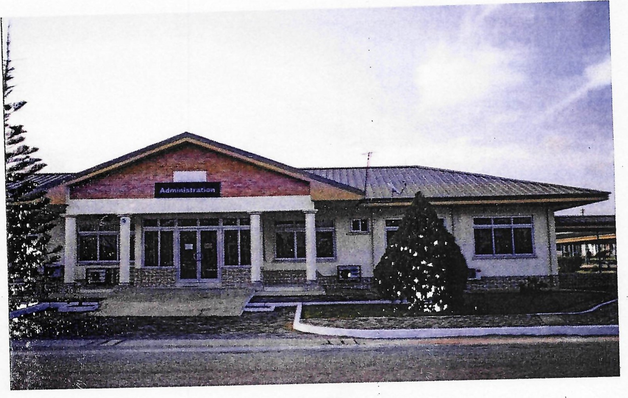
REPORT OF THE COMMITTEE
CONSTITÐTED BY THE GHANA HEALTH 3ERVICE/MINISTRY
OF HEALTH TO INVESTIGATE INT0 THE ALLEGED CASE OF ABANDONMENT OF A PATIENT AT OJOBI BY
THE TRAUMA AND SPECIALIST HOSPITAL, WINNEBA
July 2024
1 CONTENTS
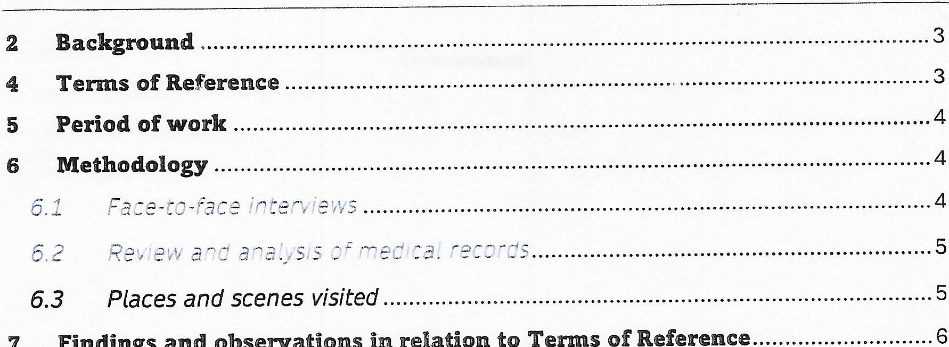
Findings
and
observations
relation
to
Terms
of
Reference
7
7.1 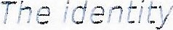 of the
7.2 Relevant events leading to Patient's adm at the trauma hospital
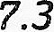Diagnosis and management of the patient at the hospital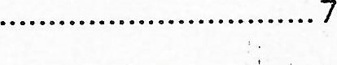
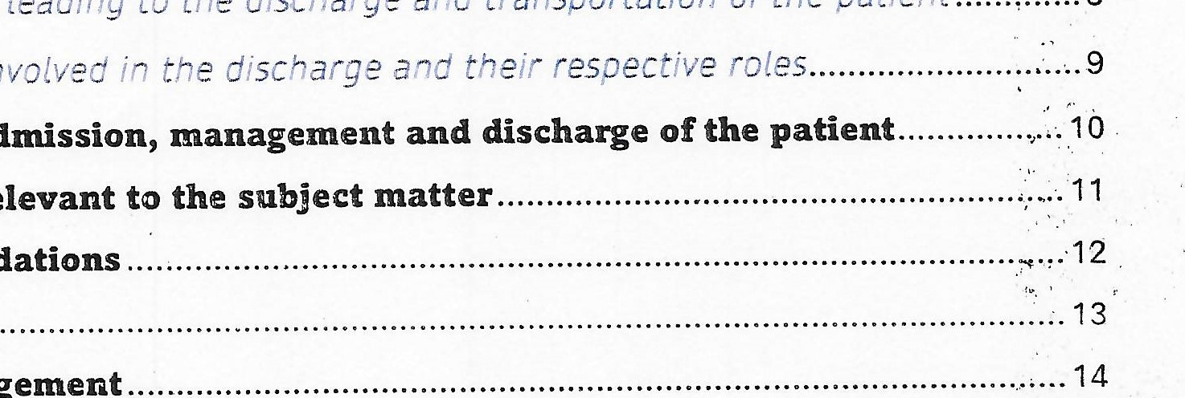
7.4 Processes
transportation
of
the
patient
leading
to
the
discharge
and
involved
in
the
admission,
7.5 Persons
- Gaps
- Other issue relevant
- Recommendations
Conclusion 13
- Acknowledgement 14
- Endorsement 14
- Appendixes 14
- BACKGROUND

Trauma and Specialist Hospital is a secondary referral facility under the management of the Ghana Health Service through the Regional Health Directorate, Central region. Following the upgrading of the former Central Regional Hospital into a Teaching Hospital, the facility was designated a regional hospital for the region and so receives referrals particularly in the areas of Trauma and Orthopaedics from other primary facilities within the region as well as adjoining regions.
On 13 ^{th} June 2024, news broke that the facility had allegedly abandoned a patient in a bush at Ojobi in the Gomoa East District of the Central Region, and that the said patient had died. This Investigative Committee was subsequently constituted and commissioned by the Ghana Health Service/Ministry of Health to unravel the facts surrounding the matter and make appropriate recommendations to enable the Service to take an informed course of action.
- THE COMMITTEE

The Committee consists of five distinguished members drawn from the various segments relevant to the case and a secretary. The table below provides details of members of the Committee.
Table T Details of Committee Members
S/N | Name | Desi nation | Role
 | Dr. Daniel Asare | Former CEO, Korle Bu Teaching Hosp and Board Chairman, Health Facilities Re ulator Authorit | Chairman
2 | Osagyefc Amanfo Edu VI | The Omanhene of Mankessim Traditional Area and representative of the Central Re ional House of Chiefs | Member
3 | Dr. Reuben Ngissah | Consultant, Trauma and Orthopaedics. Head, Department of Surgery, Greater  Accra Re ional Hos ital | Member
4 | Mr. Daniel Kudzo Fiawotror | Deputy Director, Department of Social Welfare and representative of the Ministry of Gender, Children and Social Protection | Member
5 | Mrs. Gifty Aryee | Head of Nursing and midwifery, Greater Accra Re ional Hos ital | Member
6 | Peter Obiri-Yeboah Esq | Director of Human Resources, CHS | Secretary
The Committee was inaugurated on the 20 ^{th} of June, 2024 at the Director-General's Conference Room, Ghana Health Service Headquarters.
- TERMS OF REFERENCE

The Committee had the following Terms of Reference (TOR):
    - Establish the identity and background of the patient at the centre of the matter,
    - Outline and report on all relevant events leading to the admission of the patient at the Trauma and Specialist Hospital,
    - Enquire into the diagnosis and management of the patient at the hospital,
    - Outline and report on all processes leading to the discharge and conveyance of the patient from the Trauma Hospital to Ojobi township,
    - Identify all persons involved in the discharge process and transportation of the patient from the Trauma and Specialist hospital to Ojobi as well as their respective roles
    - Outline gaps (if any) in the admission, management and discharge of the patient,
    - Report on any other issue relevant to the subject matter, and
    - Submit a report with appropriate recommendations for consideration by Friday 29th June, 2024.
However, in view of the methodology employed, the Committee could not work within the above stated time frame and same was extended to Thursday 25th July, 2024.
- PERIOD OF WORK

The Committee commenced work immediately after the inauguration on the 20th of June, 2024 and ended on Thursday 25 ^{th} July, 2024. Within the period, the Committee held six (6) sittings.
- METHODOLOGY

In gathering relevant information, the Committee employed mixed methods. This included face-to-face interviews with all relevant persons connected to the case,
review and analyses of related medical records and reports, and conducted visits to the various scenes.
  - FACE-TO-FACE INTERVIEWS
The Committee travelled to Winneba on 25th June, 2024 and held interview sessions on 26th and 27th June, 2024 with individuals whose particulars have been presented in the table below. Another interview was held on 10th July, 2024 at the Ghana Health Service, Headquarters with the Acting Regional Director of Health Service for Central Region. The prime aim of these interviews was to have unadulterated rendition of all material facts which would enable the Committee reach unbiased conclusions.
Table 2: Details of officers interviewed by the Committee
S/N |  | Name |  | Position |  | Institution
 |  | Dr. Fredovich Anyemadu Asare |  | Senior Specialist  (Orthopaedics)  Actin Medical Director |  | Trauma and Spec. Hospital
2 |  | Ms. Josephine Okine |  | Head of Nursing & Midwifery |  | Trauma and Spec. Hos ital
 | 3 |  | Mr. Tijani Khidir Saed |  | Hospital Administrator |  | Trauma and  Hos ital | Spec.
 | 4 |  | Mr. Eric Kwaku Arhinful |  | Physician Assistant with advanced trainin in s chiatr |  | Trauma and  Hos ital | Spec.
 | 5 |  | Ms Petrina Bingab |  | Nurse Manager in-charge, Female Ward |  | Trauma and  Hos ital | Spec.
 | 6 |  | Dr. Frederick Yaw Dua |  | Clinical Coordinator |  | Trauma and  Hos ital | Spec.
 | 7 |  | Mr. Evans Oddae  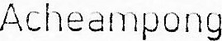 |  | Principal Hospital Orderly  (stand-in ambulance d! iver) |  | Trauma and  Hospital | Spec.
 | 8 |  | Mr. Michael Peprah |  | Temporary staff assigned as trans ort Officer |  | Trauma and  Hospital | Spec.
 | 9 |  | Dr. George Prah |  | Medical Director |  | Trauma and Hos ital | Spec.
 | 10 |  | Mr. Kwame Asante Baidoo |  | Social Worker attached to the  Trauma and Specialist Hospital |  | Department of  Social Welfare
 | Il |  | Ms. Vera Ahensowa Saah |  | Social Worker, Gomoa East  District Assembl |  | Department of  Social Welfare
 | 12 |  | Mr. Eric K. Agyapong |  | Municipal Director of Social Welfare, Winneba |  | Department of Social Welfare
 | 13 |  | Mr. Samuel Wilson |  | Nursin Officer |  | O obi Health Cent
 | 14 |  | Ms. Florence Baffoe |  | Health Promotion Officer |  | Ojobi Health Cent
 | 15 |  | Ms. Princella Tawiah |  | Senior Staff Nurse Ps chiatr |  | Ojobi Health Cent
 | 16 |  | Ms. Akua Anowa Brew |  | Nutrition Officer |  | Ojobi Health Cent
 | 17 |  | Hon. Geoffrey Inkum |  | Assembly Member, Ojobi and residin member |  | Gomoa East  District Assembl
 | 18 |  | ASP S. Asante |  | District Commander of  Police, O obi |  | Ghana  Service | Police
 | 19 |  | Chief Insp. Grace Asare |  | Kasoa MITD |  | Ghana  Service | Police
 | 20 |  | Dr. Agness A. Anane |  | Ag. Regional Director of Health Service, Central  Re ion |  | Ghana  Service | Health
  - REVIEW AND ANALYSIS OF MEDICAL RECORDS
The Trauma hospital currently operates an electronic medical record system via the Lightwave Health Information Management System (I-HIMS) platform. The team therefore reviewed copies of reports on the patient generated from the system. The team again noticed that the patient who was first seen by staff of the Ojobi Health Centre had a folder. This was therefore examined, and relevant information extracted.
  - PLACES AND SCENES VISITED
The team visited places and scenes relevant to the mater which included:

Within the hospital
a. The Accident and Emergency Ward
b. The plaster room
c. The female ward
d. The morgue (where the remains of the patient has been kept for autopsy)
Outside the hospital
a. The spot where the late patient was reported to have been picked at the outskirts of Ojobi. The gutter in which the patient laid before pickup was critically examined.
b The Committee in the company of the Assembly member for Ojobi visited the point where the patient was reported to have been dumped by the hospital and interacted with some people who live close by to the spot.
      - A visit was also paid to the Ojobi Health Centre to interact with the nurses who are on record to have reported the incident to the assembly member.
      - The Committee was again at the Ojobi District Police Command to interact with the District Commander.
      - Finally, the Committee visited the Motor Traffic and Transport Department at Kasoa Police Station.
- FINDINGS AND OBSERVATIONS IN RELATION TO TERMS OF REFERENCE

After the various interviews and review of related documents, the team presents the following findings and observations in particular reference to its Terms of Reference.
  - THE IDENTITY OF THE PATIENT
The committee finds that the late patient. neither hailed from Ojobi nor lived there during her lifetime. She was thus not known to the community. The committee established firmly that the first time the late patient was seen in the community was when she was picked from the gutter and transported to Winneba.
It was the observation of the committee that the nurse who first attended to the late patient attempted to solicit information which could help to establish her identity. However, in view of that fact that she was found to be mentally challenged, she could not provide coherent responses and since the news about her abandonment and death was widely reported in the media, no one had come forward as a relation as at the time of the Committee's visit.
In the light of the above, the Committee concludes that the late patient was mentally challenged, and did not hail from the Ojobi Community,
6
7.2 RELEVANT EVENTS LEADING TO PATIENT'S ADMISSION AT THE TRAUMA HOSPITAL
The Committee finds that:
The situation of the late patient wa; first reported to the psychiatric nurse at the Ojobi Health Centre whose particulars have been provided above (table 2 no. 11) by a passer-by.
- The said nurse, after verifying the case then invited the Assembly Member who viqited the reported the case to the social worker whose particulars have been provided above (table 2 no. 7) and left.
- It is also the finding of the Committee that the said social worker who was not at the scene remotely made all arrangements with her colleague at the Trauma Hospital whose particulars are indicated in table 2 no. 6, as well as with the National Ambulance Service for the transfer of the late patient from Ojobi to the Trauma hospital.
iv. The Committee finds that an amount of Three Hundred Ghana Cedis (GHC300.00) being fees allegedly charged by the National Ambulance Service was paid by the social worker from her own resources before the patient could be transported. However. the receipt evidencing this payment was not made available to the Committee.
It was again the observation of the Committee that the patient before transportation was cleaned, had her dirty clothes changed by the nurses at the Ojobi Health Centre and was accompanied by the psychiatric nurse who handed the patient over to the accident and emergency department of the Trauma and Specialist Hospital with a referral note
In sum, the Committee finds that the Social Worker at the Gomoa East District made all relevant arrangements for transportation and staff of the Ojobi Health Centre provided the initial care and accompanied the patient to the Trauma Hospital. The Committee commends these officers for their initial respective roles.
7.3 DIAGNOSIS AND MANAGEMENT THE PATIENT AT THE HOSPITAL
The Committee finds after a careful review of all relevant documents and imaging studies that on the first day of admission i.e. 29 ^{th} May, 2024:
The patient was well-received at the Emergency Department of the Trauma Hospital by the team of health professionals on duty.
She had two main diagnoses being:
    - Bilateral Tibiae and Fibulae Shaft Fractures
    - Mental Disorder (Possible Non- Organic Psychosis).
iii. She was adequately resuscitated on the day of admission at the Accident and Emergency Department by the team of health professionals using crystalloid and parenteral analgesics.
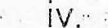Bilateral splints using Plaster of Paris were applied to both lower limbs.
Initial laboratory and radiological investigations consisting of Full Blood Count and X-Rays of both limbs were requested.

Deep vein thrombosis prophylaxis, using low molecular weight heparin
(Enoxaparin) was commenced
The Committee again finds that from day two of admission i e from 30th May, 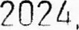the patient:
Was commenced on antipsychotic drugs being Chlorpromazine and Fluphenazine Deconoate Injection as well as anxiolytic drugs consisting of Diazepam and Amitriptyline. These spanned from 30 ^{th} May through to 2nd June 2024.
Had her laboratory investigations reviewed on 2 ^{nd} of June 2024 which showed a blood haemoglobin level of 7.6 g/dl but the clinical notes did not disclose any evidence to establish the cause of the low haemoglobin nor any attempt at correcting it.
ii i. Was discharged by the attending Physician Assistant with further training in psychiatry via hand-written notes for community integration on 3 ^{rd} June 2024 at 8:31am. The said discharge was never captured on the hospital's electronic platform, I-HIMS.
The Committee, however, finds that contrary to the claim that the patient was reviewed daily by the attending physicians, there was no documentation in the I-HIMS to support the claim.
In the opinion of the Committee, the patient was discharged prematurely considering the fact that she y ^{e}as rendered immobile from the multip ^{l}e fractures she had sustained and as such could not move around on her own as welt. as the recorded low haemoglobin level which was not addressed.
7.4 PROCESSES LEADING TO THE DISCHARGE AND TRANSPORTATION OF THE PATIENT The Committee established that:
Aside from the bilateral tibiae shaft fractures, the patient had mental health disorder which made her extremely aggressive resulting in the destruction of a hospital mattress on the ward. Although it was alleged that the patient attacked some patients in the ward. there was no evidence to confirm same.
The aggressive behavior of the patient, the Committee finds, overwhelmed the nurses at the female ward. The Deputy Director of Nursing Service in-charge of the hospital was subsequently informed. She thus collaborated with the social worker and got the assistance of the Physician Assistant (Psychiatry) for the patient to be discharged from the hospital.
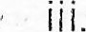 The Committee finds that the above arrangement is contrary to established processes or formalities at the Trauma and Specialist Hospital where patients are properly discharged by attending doctors.
- The transport officer upon request from the Deputy Director of Nursing Service and the subsequent approval of the medical director released the hospital's ambulance for the purpose of transporting the patient out of the hospital.
- Since there was no driver readily available, the transport officer arranged for the principal hospital orderly whose particulars have been provided in table 2 no. 7 to convey the patient to Ojobi.
- The dispatch team was made up of the social worker attached to the hospital, the principal orderly i.e. stand-in driver, a student nurse and a grounds worker. It was observed that this trip was not recorded in the transport records/logbook of the facility.
- The patient was conveyed out of the hospital without a clear knowledge of destination, no accompanying medications and without any plan for family reintegration as well as reviews.
- The patient was quietly abandoned in a wheelchair at a place outside of town and off-the main road, about 200 meters from the Ojobi Health Centre in an open space and was therefore exposed to the conditions of the weather.
The Committee finds the discharge process, transportation and community integration inappropriate and in sharp contrast to existing best practices.
7.5 PERSONS INVOLVED IN THE DISCHARGE AND THEIR RESPECTIVE ROLES
The committee identifies the following officers as key in the discharge process:
Table 3: particulars of officers involved in discharge and evacuation ofpatient
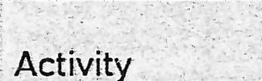  Activit | Persons Involved |   Role
Discharge of patient | Deputy Director of Nursing in-charge of the hos ital | Spearheaded arrangements to get the patient out of the ward without adherence to proper dischar e rotocol
 | Physician Assistant | Certified manually that the patient was mentally stable and proceeded with discharge without recourse to rotocol
Transportation of patient from the Trauma  Hospital to Ojobi | Transport Officer | Arranged for hospital ambulance, a stand-in driver and fuel for the patient to be taken awa
 | Principal Hospital Orderly | Drove the ambulance conveying the patient from the Trauma Hospital to Ojobi upon the instructions of the trans ort officer

 | Medical Director | Authorized the release of the ambulance even though the committee did not find any evidence to confirm that he had full knowledge of who was to be taken out of the and where he/she was to be taken to
 | Social Worker | Led the team to the point where the patient was abandoned
g CAPS IN THE ADMISSION, MANAGEMENT AND DISCHARGE or THE PATIENT

After extensive review of relevant documents and face-to-face interviews, the Committee identifies the undermentioned as gaps in relation to the various subheadings.
- Admission
There was no formal referral letter from the social worker in Gomoa East district to her colleague social worker at the Winneba Trauma Hospital. This is contrary to the social welfare case management standard operating procedures as provided for in appendix 3.
The Trauma Hospital upon receiving the patient who was described in the referral letter to have been knocked down by a vehicle should have formally notified the police. However, no such report was made but the patient was received, attended to and moved to the ward.
- Management
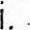Documentation on the patient's daily progress was scanty and not thorough. This applies to nursing, medical and social welfare.
Although the hospital was aware of the patient's low haemoglobin level which was recorded to be 7.6g/dl upon admission, no investigation was conducted to ascertain the cause in order to correct the situation or any intervention instituted to shore up the low haemoglobin level.
  - The psychiatric care extended to the patient was sub-optimal. Although, the hospital has a good number of psychiatric nurses who could have provided continuous psychiatric nursing care to the patient, there were no records to show their involvement in her management.
  - Non-availability of dedicated financial support was a hinder-ance to care. Since the hospital relied solely on imprest approved and released by the medical director, care was restricted to what the imprest could afford.
- Discharge
Protocol for discharge was not followed. Contrary to the wellestablished practices across the levels of the Service, the patient was discharged not because she was fit to go home but because she had become a nuisance to the facility especially the nurses who attended to her.
1
ii. Although the patient was taken out of the hospital, documentation as captured on the LHIMS indicated she had not been discharged as no corresponding entries were made.
 The patient was discharged without any evidence of home tracing, family preparation or community reintegration. Indeed, she was taken away from the hospital without any knowledge of where she was supposed to be sent to.
  - There was no post-discharge care continuum for the patient. The patient was sent out without any medication for both anaemia and mental health disorder as well as when to report for reviews.
  - The patient, instead of being sent to the community, the Trauma hospital had the option of referring her to either Cape Coast Teaching Hospital or Ankaful Psychiatric Hospital for continuous management.
  - For long term care, the late patient could have equally been referred to the Central Destitute Infirmary situated at Bekwai in the Ashanti region as evidence clearly showed that she had no home.
- OTHER ISSUE RELEVANT TO THE SUBJECT MATTER

The Committee in addition to the above identified the following as relevant to the subject matter:
  - Issues relating to the alleged accident involving the patient
The Committee after visiting all the relevant sites and interacting with the police at Ojobi and Kasoa concludes that the said patient must have been knocked down elsewhere and dumped at the outskirts of Oiobi since there was no case of accident recorded within the vicinity at the said period. Additionally, the possibility of sustaining bilateral tibiae fractures is unlikely by falling into the gutter which was found to be shallow.
  - Ineffective hospital management system in Operation
The Committee observed the management system in place at the Trauma Hospital to be in sharp contrast to other similar secondary level health facilities. The committee's observation is in reference to the undermentioned four key hospital management members.
    - The Medical Director
It was observed that the medical director performed both administrative and support functions which are supposed to be the principal duties of other officers. For instance, the Committee noted that staff had to see him personally for imprest for petty supplies, approval for use of hospital vehicles including ambulance and issuance of fuel chits. The above, the
1
Committee notes, is contrary to best practice in hospital management within the Ghana Health Service.
    - The Clinical Coordinator
The role of the clinical coordinator in the provision of quality healthcare in CHS facilities cannot be over-emphasized. However, the situation at Trauma was observed to be different as the clinical coordinator had minimal knowledge about what went on In the facility as far as clinical care was concerned. The Committee was intrigued to note that the clinical coordinator knew nothing about the admission and discharge of the patient under consideration.
    - The Head of Nursing and Midwifery
The head of nursing and midwifery in-charge of the hospital was observed to exercise a lot of powers in all spheres of the hospital management with the overt approval of the medical director. In the instant case, she was observed to have veered into general administration, financial management, transport management and clinical coordination contrary the practice in the Ghana Health Service.
    - The Hospital Administrator
The Hospital Administrator was observed to have no knowledge about the instant case. The Committee finds this intriguing as a temporary employee who worked directly under his supervision was actively involved in the transportation of the patient from the hospital to Ojobi.
  - Absence of key protocols in wards
A visit by •the Committee to the wards revealed that important nursing and midwifery protocols for admission, and discharge were not available. There was also no demonstration of total nursing care which is a standard practice for Ghana Health Service facilities.
  - Display of dishonesty
The Committee observed that almost all persons who appeared before it rehearsed and presented fabricated stories to conceal respective shortcomings in the case under investigation. It took a lot of probing and document review which projected the various inconsistencies, disagreements and contradictions in the various accounts rendered by respective officers.
- RECOMMENDATIONS

Based on the findings, gaps identified as well as other issues outlined as relevant to the instant case, the Committee makes the following recommendations:
|
That.
1. The employees of the Ghana Health Service who have been identified in table 3 as having contributed to the planning and evacuation of the patient from the hospi ^{Ç} al to Ojobi where she was abandoned ard Left at the mercies of the weather until her demise did not act appropriately. The Ghana Health Service should therefore take them through the established disciplinary processes for applicable sanctions according to their respective roles.
2 Since the social welfare officer attached to the hospital i.e. Mr. Kwame Asante Baidoo is not an employee of the Ghana Health Service, he should be released from the hospital and formally reported to his mother agency, the Department of Social Welfare for him to be taken through their internal disciplinary process.
  - There should be extensive capacity building for the various cadre of staff at the Winneba Trauma Centre on the use of approved protocols and clinical documentation.
  - The Ghana Health Service must revamp the management system at the Trauma Hospital for efficiency and improved quality of care.
  - The Ghana Health Service issues a directive for the setting up of dedicated fund for paupers at the various facility in the interim and engage the National Health Insurance Authority to chart out modalities for facilities to submit claims of such patients for reimbursement.
  - The Ghana Health Service/Ministry of Health should take steps to remove financial barrier to accessing mental health care and look at putting mental health services on NHIS minimum package scheme as recently done with dialysis.
The Ghana Health Service should expedite action for the conduct of autopsy to establish the actual cause of death as requested by the coroner.
8. The Ghana Police Service should assist in identifying the alleged hit-and-run driver as well as the identity of the said woman in the missing persons database.
- CONCLUSION

The content of this report is an outcome of a thorough and independent examination and analyses of all material facts of the instant case. Throughout the process, the Committee was guided by the stated Terms of Reference and the need for interventions necessary for forestalling the reoccurrence of the unfortunate incident which occasioned the setting up of the Committee. The Ghana Health Service/Ministry of Health is thus entreated to ensure full implementation of recommendations contained in this report.
1
- CONCLUSION
The content of this report is an outcome of a thorough and independent examination and analyses of all material facts of the instant case. Throughout the process, the Committee was guided Cy the stated Terms of Reference and the need for interventions necessary for forestalling the reoccurrence of the unfortunate incident which occasioned the setting up of the Committee. The Ghana Health Service/Ministry of Health is thus entreated to ensure full implementation of recommendations contained In this report.
- ACKNOWLEDGEMENT

The Committee expresses a heartfelt gratitude to all persons who contributed in various ways for the successful completion of this all-important assignment. The Committee is particularly grateful to the appointing authority i.e. the Ghana Health Service/Ministry of Health for the confidence and trust reposed in personalities selected and commissioned to undertake this all-important assignment. Specifically, the following are acknowledged•
The Honourable Minister for Health
The Honourable Minister for Gender, Children and Social Protection
The Director-General of the Ghana Health Service
The President of the Central Regional House of Chiefs
The Chief Director, Ministry of Gender, Children and Social Protection
- ENDORSEMENT

Members of the Committee hereby put their names and hands to this report and confirm same as the true outcome of investigations conducted on the case under reference.
S/N | Name | Role | Signature
 | Dr. Daniel Asare | Chairman | 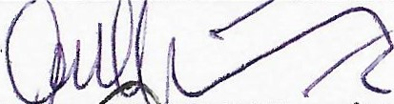
2 | Osagyefo Amanfo Edu VI | Member | 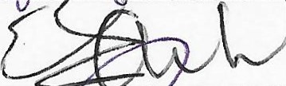
3 | Dr. Reuben Ngissah | Member | 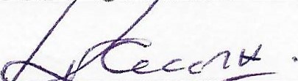
 | Mrs. Gifty Aryee | Member | 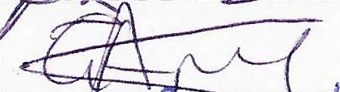
5 | Mr. Daniel Kudzo Fiawotror | Member | 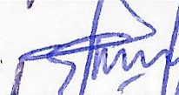
6 | Peter Obiri-Yeboah Esquire | Member/Secretary
1
- APPENDIXES

  - . Terms of Reference
  - Referral Letter from Ojobi Health Centre 3 Social Welfare Case Management Forms
  - Mental Health Authority Letter
  - Patient Record printout from I-HIMS/handwritten records
  - Pictures
|

In case or reply the number and the date Of this letter should be quoted

Our Core Values
- Professionalism Discipline Integrity
Teamwork
- Innovation & Excellence
People Centred
My Ref. No. GHS/HRD/ODHR/2024/06 Your Ref.........
DISTRIBUTION

GHANA HEALTH SERVICE PRIVATE MAIL BAG MINISTRIES ACCRA
Tel. 0302-661354
Fax. 0302-670329/660472

Yaur Health • Our Concern
June 20, 2024

ALL COMMITTEE MEMBERS
NOMINATION TO SERVE ON A COMMITTEE CONSTITUTED TO IN STIGATE THE ALLEGED ABANDONMENT OF A PATIENT IN A BUSH AT GOþ4ÓA OJOBI BY THE TRAUMA AND SPECIALIST HOSPITAL, WINNEBA-
You have been nominated to serve on a committee constituted by the Ghana Health Service to investigate the alleged abandonment of a patient who was later found dead in a bush at Gomoa Ojobi by the Trauma and Specialist Hospital, Winnebaa The composition of the Committee is as tabled.
SIN | I Name | Desi nation | Role
1 | Dr. Daniel Asare | Former CEO, Korle Bu Teaching Hosp | Chairperson
2 | Osagyefo Amanfo Edu vg | Omanhene of Mankessim  . of Central Re ion House of Chiefs | Member
3 | Dr. Reuben Ngissah | Consultant (Orthopaedics) Ridge Hosp | Member
4 | Mr. Daniel K. Fiawotror | Deputy Director, Dept. of Social Welfare | Member
5 | Mrs. Gifty Abankwah Aryee | Head of Nursing, Ridge Hospital | Member
6 | Peter Obirï-Yeboah Esq | Director of Human Resources, GHS | Secretary
The Committee has the following Terms of Reference:
1. Establish the identity and background of the patient at the centre of the matter,
2. Outline and report on all relevant events leading to the admission of the patient at the Trauma and Specialist Hospital
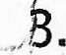 Enquire into the diagnosis an management of the patient at the hospital,
- Outline and report on' all processes leading to the discharge and conveyance of the patient from the Trauma Hospital to Ojobi township,
- Identify all persons involved in the discharge process and transportation of the patient from the Trauma and Specialist hospital to OjQbi and their respective roles,
- Outline gaps (if any) in the admission, management and discharge of the patient,
- Report on any other issue relevant to the subject matter, and
- Submit a report with appropriate recommendations for consideration by Friday 29th June, 2024.
It is our hope that you will bring your rich experiences to bear on the work of the committee so that the Ghana Health Sewice will be able to institute appropriate measures to pre-empt the reoccurrence of the unfortunate incident.
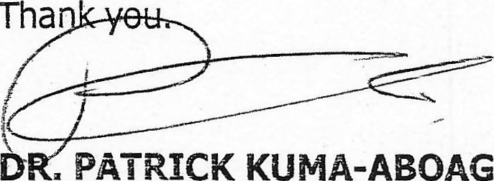PATRICK KUMA-ABOAGYE DIRECTOR-GENERAL, GHS
Tha
cc:
The Hon. Minister for Health Ministry of Health, Accra
ii a The Chairman
Ghana Health Service Council
iii. The Chief Director
Ministry of Gender, Children and Social Protection Ministries-Accra
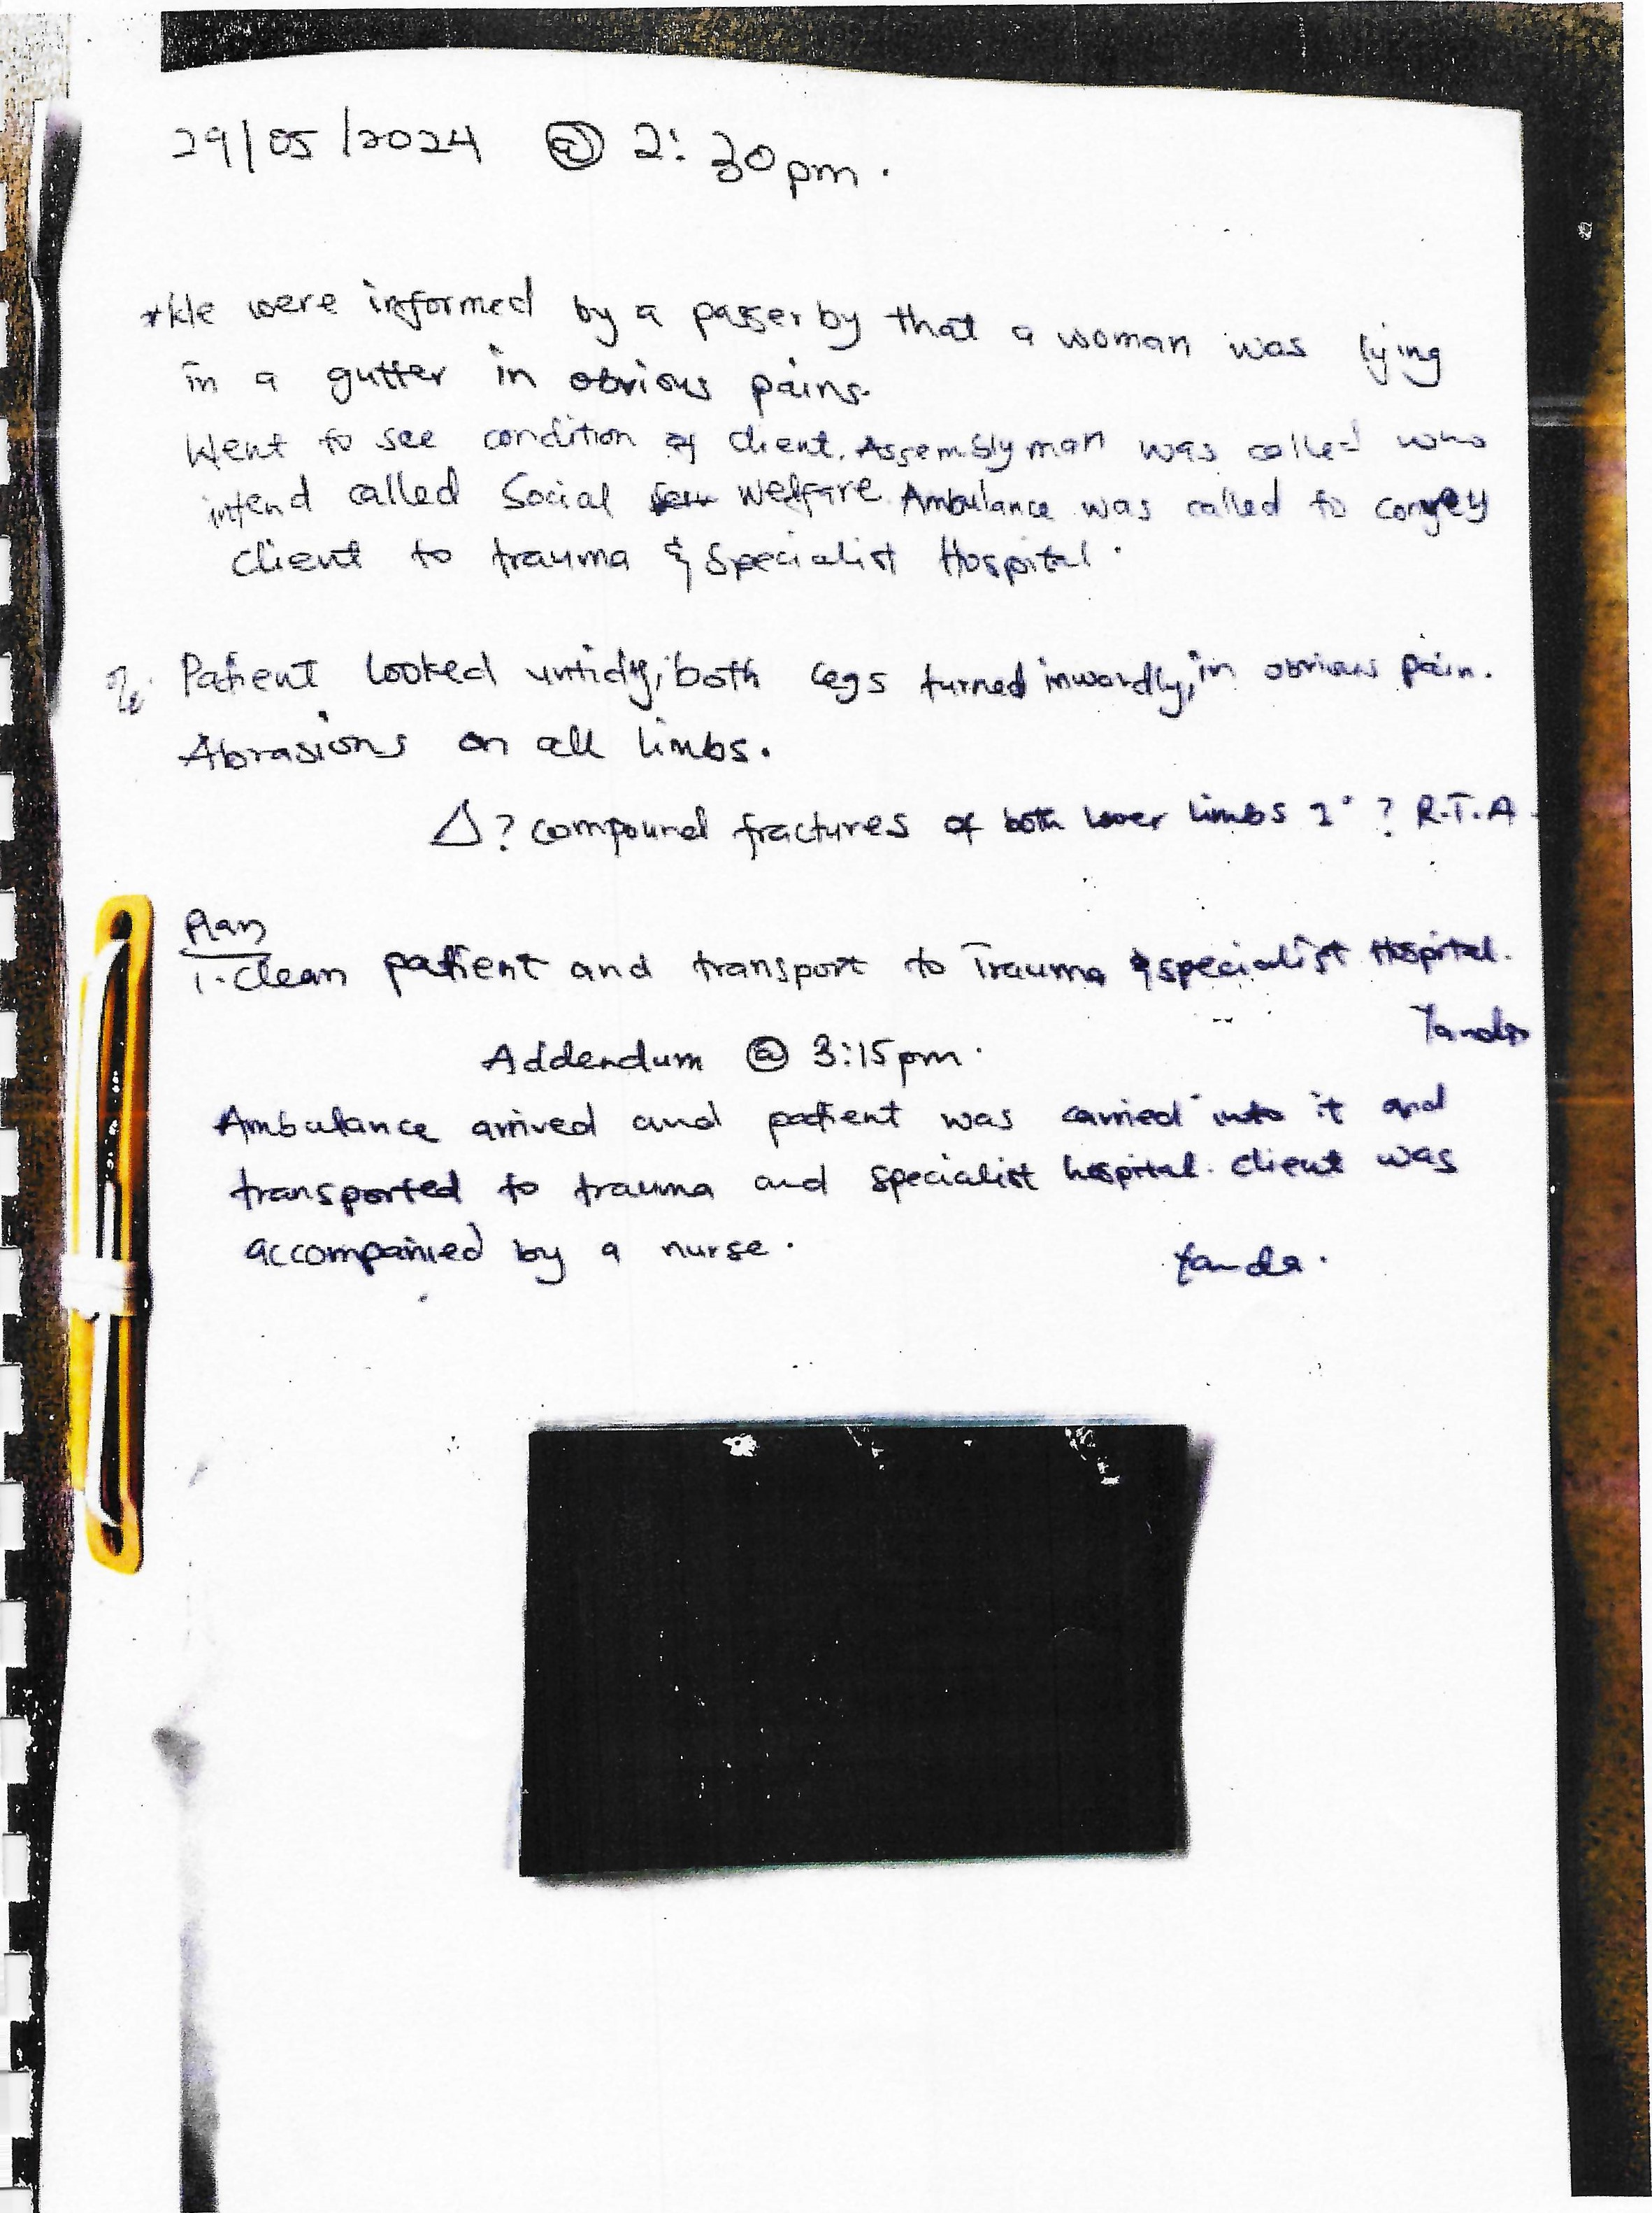

Case Registration
Department of Social Welfare (Confidential)
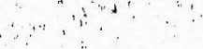
Case Registration Form [Form #1]
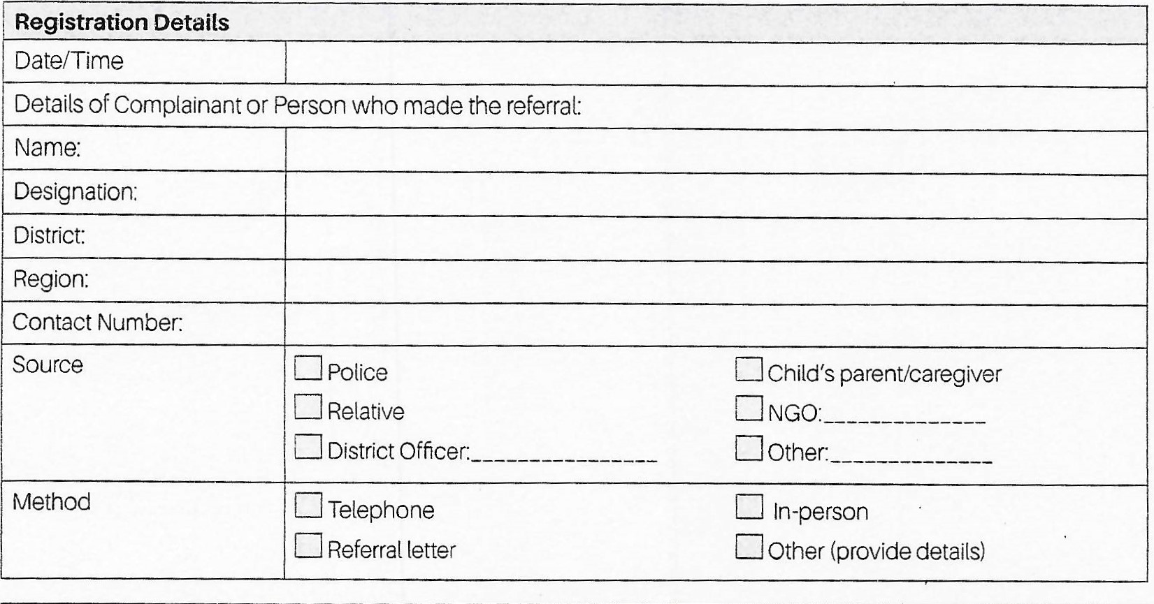
Child and Family Details
Child's Surname
Child's Name (first and middle)
Other Name/Child's Nickname (where applicable)
Sex | Malea |  | 
Date of Birth |  |  | Age:
Religion
Address/tocation (street/landmark, district, region,)
Who does the child currently live with?
Mother Name/Surname |  | DOB/Age |  | Status21•
Address (include District 8 Region)
Father Name/Surname |  | DOB/Age |  | Status:
Address (include District 8 Region)
Caregiver Name/Surname |  | DOB/Age |  | Status:
Address (include District 8 Region)
Alive, deceased, unknown


Case 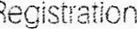 Form [Form
Child and Family Details
Names, sex and bil thdates (and ages; of other children in the family
Protection concerns (tick all boxes that apply)


C] Physical abuseChild neglectOrphanhood - double or single
Sexual abuseExploitationChild maintenance
C] Child custody Abandonment Other, specify: _____
Provide additional details on the reasons for referring the case:
Follow-up action to be taken
12 Further investigation needed
Referral of case to ._ Other, specify.
Action to be taken:
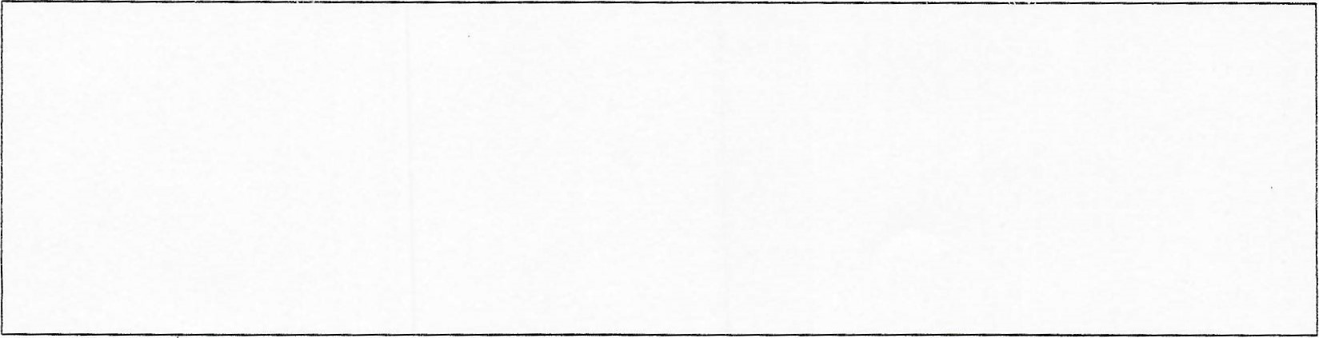
Details of officer who register the case and received the referral
Name

Designation Signature:
Social Enqú:r; Reoor: Form _

Department of Social Welfare
(This report is confidential and is meant for the purpose of the Family Tribunal Proceeding) Social Enquiry Report [Form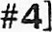
Date:
Child and Family Details
Child's SURNAME
Child's NAME (first and middle)
Other name/Child's
Nickname (where applicable)
Sex |  | M ale |  | Female
Date of Birth |  |  |  | Age:
Religion
Address (street, landmark district, region)
Who does the child currently live with?
MOTHER name/surname |  |  | DOB/Age |  | Status22.
Address (include District Region)
Mother's occupation
FATHER name/surname |  |  | DOB/Age |  | Status:
Address (include District 8 Region)
Father's occupation
CAREGVER name/surname |  |  | DOB/Age |  | Status:
Address (include District & Region)
Names, sex and birthdates (and ages) of other children in the family
3. Case referral and investigation Who referred the case and why.
Who was consulted, home visits, time spent conducting the investigation
Sociai Enquiry Report Form [Form
- Background of child
Brief family history
What are the circumstances that led the child to be found in need of care and protection?
- Home circumstances
What are the physical conditions of the home?
Family relations - parents, children, other adults in the home Family strengths
- Findings
Summary ofkey findings on whether child is in need ofcare and protection or not.
Capacity ofparents or extended family to care for the child in the immediate and longer term
- Social worker recommendations
What are the recommended actions for this case? is recommended to place the child in formal alternative care what steps have been taken to identify other options e.g. family strengthening services and/or placement

with relatives in informal kinship care.
Name 8 Position of person who compiled the SER |  | Date
District Office: | Region:
Supervisor/ name and signature: Date
²² Alive, deceased, unknown


Department of Social Welfare Referral Form [Form#10]
Date:
Referral from:
Department (District/Region) ___
Referral to:
Name of organisation
Address of organisation
Dear
We are referring (name of client)_____ to you to receive relevant services. The reason for the referral and the services required is as follows:

Thank you in advance for your help with this referral. We look forward to your prompt feedback to assist with the management of this case. Please complete and return the attached form [Referral Response Form#11].
Sincerely,

Case Manager/SWCDO
Telephone:
Email: Address: _


Referral Response Form 'Farm l. CASE REF
Department of Social Welfare
Referral Response Form [Form#11]
Dear (case manager/SWCDO)
We have received your referral to assist your client whose name is

We understand that you would like us to provide the following services:

At this time we are (please tick one):
Able to provide the service/s
Unable to provide the service/s
Willing to your client on a waiting list
We understand you will call to check on the progress of your client.

(Name of person filling out the form and title)
Telephone:
Email:

RESPONSES TO ENQUiRY
1. Was the Ankaful Psychiatric Hospital contacted so that a case at the Trauma Speciaiist Hospital, Winniba (TSHW), could be referred there (i.e., Ankaful)?
Response: The Social Welfare Officer (SWO) attached to the Ankafui Psychiatric Hospital (AnPH) said that he received a call from his colleague (Vera) from the Gomoa East Municipality enquiring about the process involved in admitting a vagrant patient. However, he failed to inform anybody in the clinical team or management about this interaction. Management found out these details from the SWO attached to AnPH when he was engaged following the release of a formal report by the SWO attached to TSHW, indicating that they had contacted AnPH.
2. Is there a policy that any patient to be referred to the hospital should be able to move around?
Response: There is no such policy that patients referred to the Ankaful Psychiatric Hospital (AnPH) should be able to move around. However, managerrìent found out from our interaction with the SWO attached to the facility that he explained to his colleague during the call that, based on past experiences, they would need to bring the patient to the outpatient department to be assessed clinically for the suitability of admission to AnPH. Based on the assessment, the clinical team will adopt the appropriate treatment plan, strategy, and approach to manage the case, as this is the standard procedure.
- As per (1) above, was the Trauma hospital told to come along with GH 9,000.00 cedis as a deposit before a case would be accepted or received?
Response: No. In their phone conversation on the matter, the SWO attached to AnPH indicated to the SWO at Gomoa East that if the patient were to require admission following assessment at the AnPH OPD, the District Assembly would need to make arrangements to pay an advance to cover three (3) months of admission charges. This was based on the practice for some time now when vagrants have to be moved to the psychiatric hospital, AnPH engages the relevant district assemblies to pay at least three months of hospital bills to avoid a situation where vagrants are dumped or abandoned in the hospital to care for. In many instances, however, the patients have ended up being admitted to the hospital without the assemblies necessarily paying or playing their part in the patients' care.
- Is Mt-IA aware of these policies?
Response: The practice of engaging relevant district assemblies through their social welfare departments to pay for and be responsible for the care of persons with mental disorders found in public places of their respective districts is backed by law. Indeed, Section 73, subsections 4, 6, and 7 of the Mental Health Act, 2012 (Act 846) state as follows:
  - (4) A District Assembly is responsible for the well-being of persons with mental disorders found in public places in the district
  - (6) A District Assembly shall ensure in consultation with the appropriate agencies that a person with a mental disorder found in a public place after treatment is adequately rehabilitated and integrated back into society
  - (7) A District Assembly shall make adequate budgetary allocation for the care of persons with mental disorders found in public places within the district.


&
Patient Information
Surname: | UNKWON | Other Names: | UNKWON
Patient No.: | WI-A01-AAH6008 | Gender: | Female
DOB: | 01-01-1979 | Age: | 45 Year(s)
Admission Date: | 29-05-2024 | Admission Time:
Admission NO.: | ADMT-54321

Ward/Room History
 | Ward/Room | Bed No. | From Date | From Time | To Date | Time | Transfer Reason | Status
1 | Ward Trauma A/ E  DETENTION BEDS | 11 | 29-05-2024 | 16:14 | 31-05-2024 | 16:14 | For feather Treatment | Bed Changed
 | WWårdŽTraUiñå OrthOÞeadic;and GenêraEFemáie •Wafd (TOGF-WY | 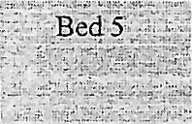 | 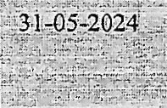 | 16:14 | 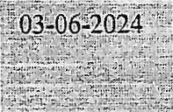 |  |  | 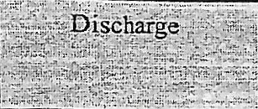
at
m ntD tail
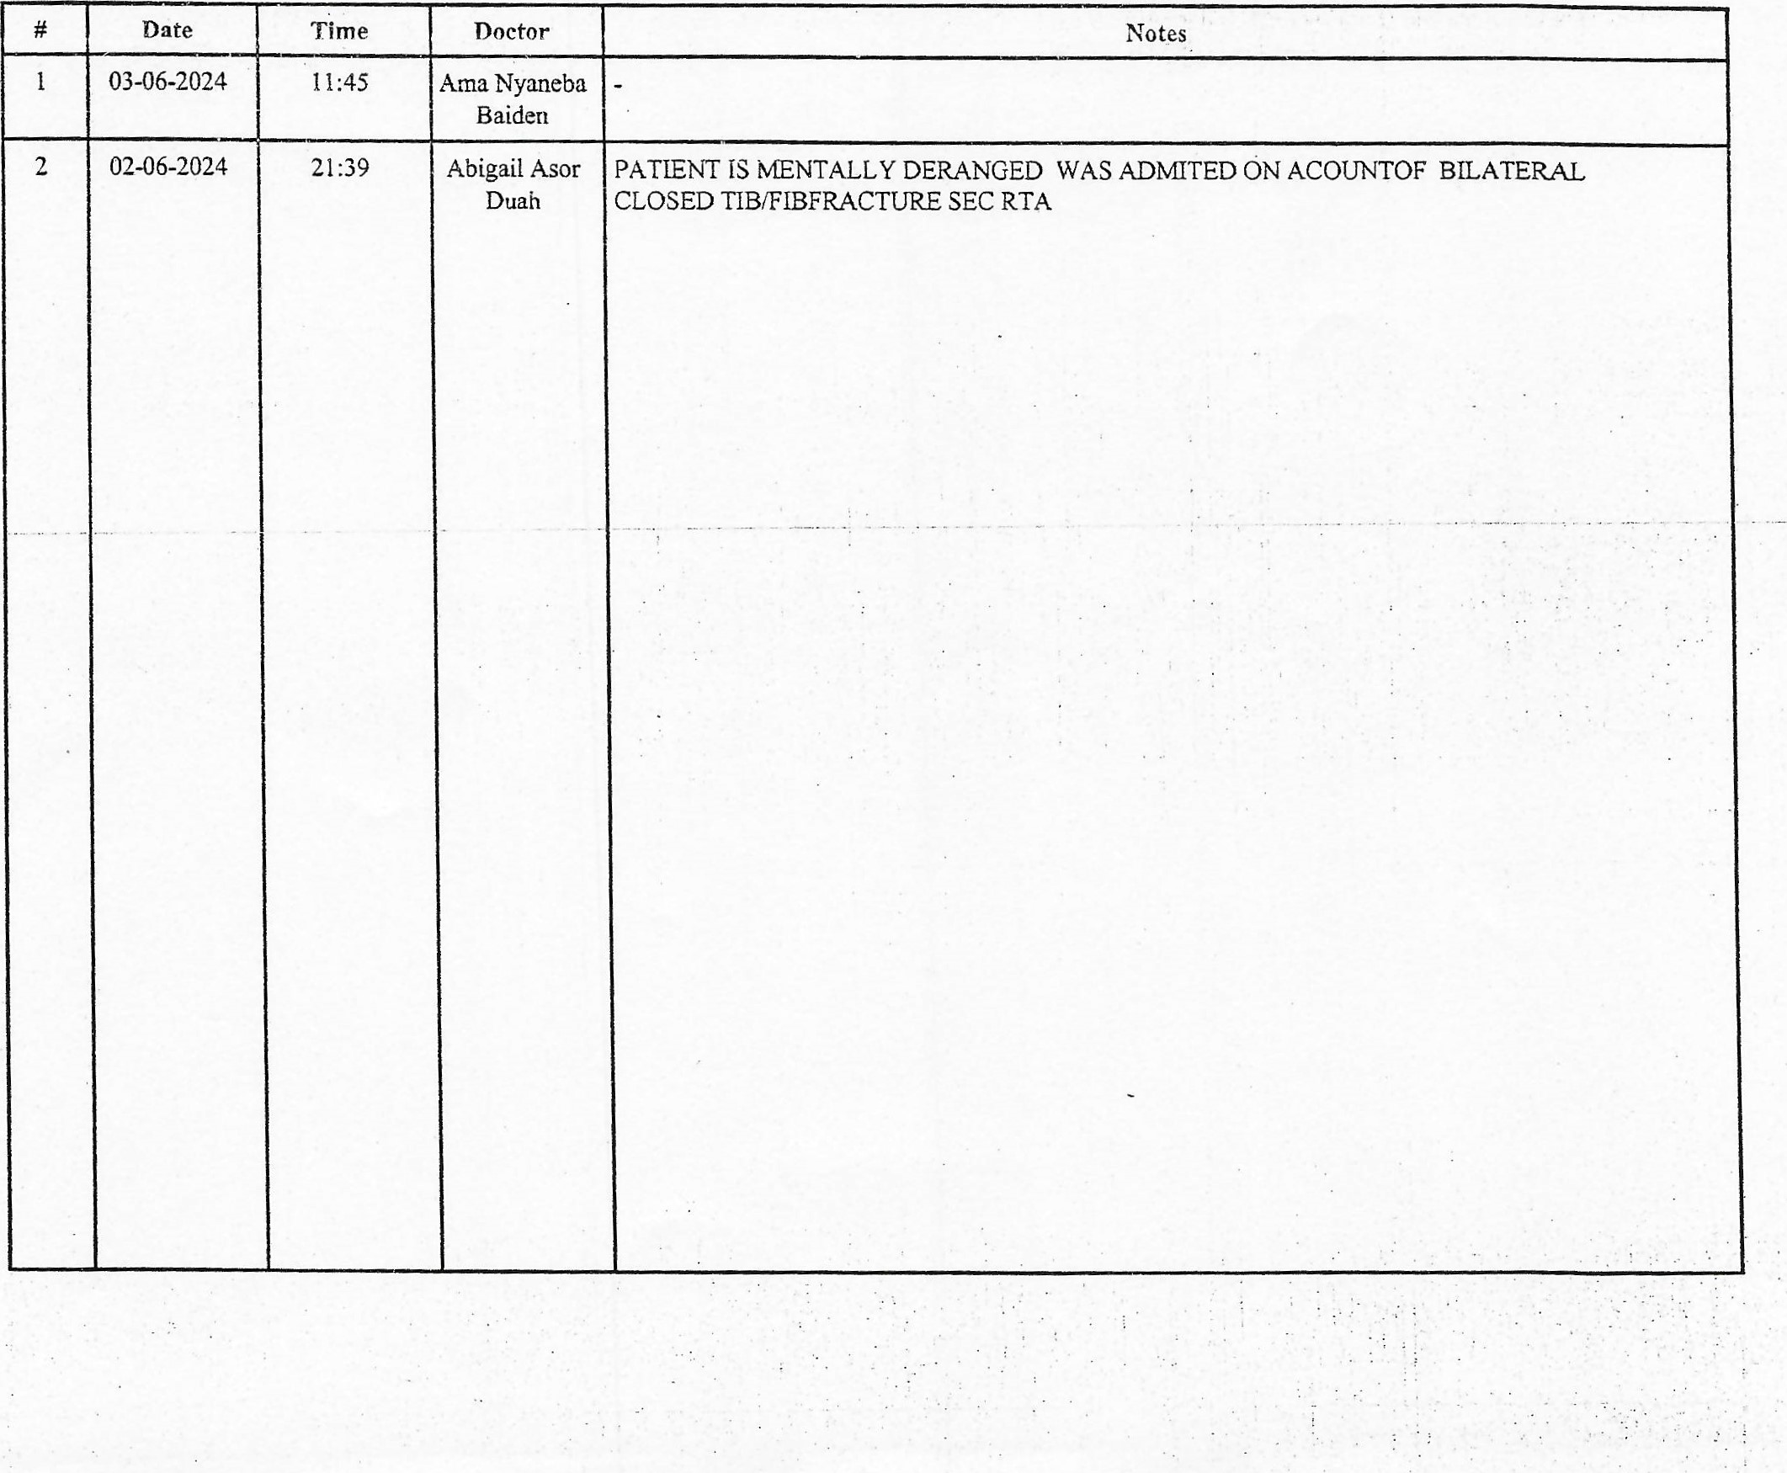
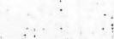


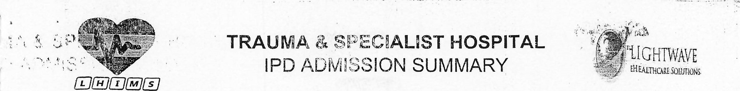
 | Date | Time | Doctor | Notes
3 | 02-06-2024 | 14:16 | DR.  MICHAEL SEFA  SARPONG | PATIENT rs ^{M}ENTALLY DERANGED WHICH MAKES TT DIFFICULT TO BE REVTEwED  BEING MANAGED AS A CASE OF BILATERAL CLOSED TIB/FŒFRACTURE SEC RTA  CURRENTLY ON  DICLOFENAC 75MG BD X 5/7  - TAB AMOKSICLAV 625MG BD X 5/7  - SC ENOXAPARIN 40MG DAILY X 48 HRS (COMPLETED)  LABS DONE (29/5/24)  HB - 7.6 G/DL  PLT 285 X  WBC - 16.4 X IO^{A}/L  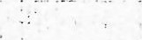  COULD NOT BE ASSESSED DUE TO NŒNTAL NSTABŒILITY  O/E - AN ELDERLY FEMALE PATIENT WITH BACK SLAB ON BOTH LOWER LIMBS, NOT IN ANY OBV RESP DISTRESS, PALE, ANICTERTC, MODERTAFLY DEHYDRATED.  VITALS NOT DONE DUE TO CONDITION  CNS - CONSCIOUS, GCS 15/15  CVS- Sl + S2, MO.  RESP - CHEST rs CLNICALLY CLEAR  ABD - FLAT, SOFT, MWR, NON TENDER, NO MASSES, NO ORGANOMEGALY, BOWEL  SOUNDS PRESENT.  SL - BOTH LOWER LIMBS BACK SLAB  PLAN  - TO DO XRAY OF BOTH LOWER LIMBS    - DISCUSS wiTH ORTHOPAEDIC TEAM 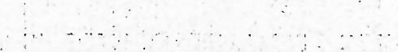
4 | 31-05-2024 | 09:20 | EVANS WL  BERFORCE ANOKYE | 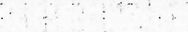
5 | 30-05-2024 | 17:35 | P.A  Mensah
6 | 30-05-2024 | 17:34 | P.A Patricia Mensah
7 | 30-05-2024 | 15:31 | Regina  Fordjour  Marfo


 | Date | Time | Doctor | Notes
8 | 30-05-2024 | 13:41 | P.A  MAUDRIN  ADOO
9 | 29-05-2024 | 17:49 | Fuseini mohammed  Zakaria
10 | 29-05-2024 | 17:03 | EVANS  BERFORCE ANOKYE


Recommendations
 | Procedure Name | Recommended Date | Notes
1 | Full Blood Count FBC (Automation)
2 | Typhoid Rapid Test | 29-05-2024
3 | BF for Malaria Parasites | 29-05-2024
4 | TibiaÆibula | 30-05-2024 | BOTH
Prescriptions 
 |  | Drug Name | Frequency | Dose | Days | Quantity
1 |  | Sodium Chloride Injection, 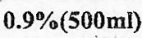 [Sodium Chloride  Injection 0.9%(500ml) 1 0.9%(500ml) l. Infusion - From  29-05-2024 To 29-05-2024] | TDS | 500 ML | 1
2 | - | Dextrose in Sodium Chloride Intravenous Infusion, 5% in [Dextrose in Sodium Chloride Intravenous Infusion, 5% in | 5% in 0.9% (500m1) I Infusion -  From 29-05-2024 To 29-05-2024] | BDS | 500 cc | 1
 |  | ANTI-TETANUS SERUM [ANTI-TETANUS SERUM | 1500  I.U. I Injection - From 29-05-2024 To 29-05-2024] | Stat | 1500 IU | 1 | o
4 |  | Diclofenac Injection, 75 mg/3ml [Diclofenac Injection, 75 mg/3mI 75 mg/3ml I Injection - From 29-05-2024 To 29-05-2024] | Stat | 75 MG | 1
5 |  | Diclofenac Capsule, 75 mg [Diclofenac Capsule, 75 mg | 75 mg I Capsule - From 29-05-2024 To 02-06-2024] | BDS | 75 MG | 5 | 10
6 |  | Amoxicillin + Clavulanie Acid Injection, 1.2g  [Amoxicillin+Clavulanic Acid Injection, 1.2g 1 1.2g I Injection From 29-05-2024 To 29-05-2024] | Stat | 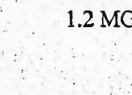  MG | 1 | 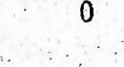
7 |  | Amoxicillin + Clavulanic Acid [Amoxicillin + Clavulanic Acid 625 mg 1 500mg+125mg I Tablet - From 29-05-2024 To 02-06-2024] | BDS   | 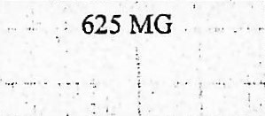 | 5 | 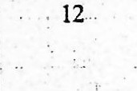  12
8 |  | Giving Set IV Disposable Adult I NA I Injection - From 29-05-2024 To 29-05-2024] | Stat | 1 inch | 1
9 |  | Fluphenazine Deconoate Injection 25mg/ml [Fluphenazine  Deconoate Injection 25mg/ml 1 25mg/ml t Injection - From 30-05-2024 To 30-05-2024] | Stat | 25 MG | 1
10 |  | Chlorpromazine Injection [Chlorpromazine Injection | 25 mg/mL in 2 mLInjection I Injection - From 30-05-2024 TO 30-05-2024] | Stat | 50 MG | 1 | 1



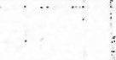

&

 | Drug Name | Frequency | Dose | Days | Quantitv
It | Chlorpromazine Injection (Chlorpromazine Injection ! 25 mg/mL in 2 mLInjection I Injection - From 30-05-2024 To 30-05-2024] | Stat | 50 MG | 1 | 0
12 | Diazepam Injection, 5 mg/ml in 2 ml [Diazepam Injection, 5 mg/ml in 2 ml | 5 mg/ml in 2 ml I Injection From 30-05-2024 To 30-05-2024] | Stat | 10 MG | 1
13 | Chlorpromazine Injection [Chlorpromazine Injection | 25 mg/ml, in 2 mLInjection Injection - From 31-05-2024 To 02-06-2024] | BDS | 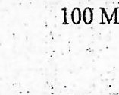  MG | 3
14 | Diazepam Injection, 5 mg/ml in 2 ml [Diazepam Injection, 5 mg/ml in 2 ml | 5 mg/ml in 2 ml f Injection - From 31-05-2024 To 02-C6-2024] | BDS | 10 MG | 3
15 | Dextrose in Sodium Chloride Intravenous Infusion, 5% in [Dextrose in Sodium Chloride Intravenous  Infusion, 5% in 0.9%(500ml) | 5% in 0.9% (500ml) I Infusion From 31-05-2024 To 01-06-2024] | BDS |  | 2
16 | Giving Set IV Disposable Adult Ù4A I NA I Injection - From 31-05-2024 To 31-05-2024] | Stat | I cc | 1
17 | Amitriptyline [Amitriptylline | 25 mg I Tablet - From 02-06-2024 To 04-06-20241 | Nocte | 50 MG | 3 | 6
Doctor & Nurse Notes
 | Notes | Type | Added By | User Type | Added On
1 | PATIENT HAS BEEN SHOUTNG AND CLAPPING  THROUHOUT THE NIGHT,AWAKE THIS MORNING WITH  PATENT STILL CLAPPING AND SHOUTING.VITAL  SIGNS CHECKED AND RECORDED, DUE NŒDICATIONS  SERVED. ALL NEEDED NURSNG CARE  PATIENT REASSURED AND MADE CONFORTABLE  BED. CONDITION IS STABLE, AWAITING MOS REVŒW. | Nurse Notes | 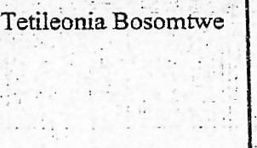 | 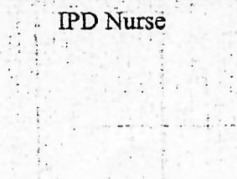 | 03-06-2024 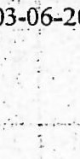 05:25
2 | AT IOPM,VITAL SIGNS CHECKED AND RECORDED, PATENT IS MADE COMFORTABLE IN BED AND REASSURED. | Nurse Notes | Tetileonia Bosomtwe | IPD Nurse | 02-06-2024 22:33
3 | PATIENT WAS OBSERVED ON THE FLOOR FROM THE  BED, DESTROYED EVERYTHING IN THE ROOM AT 1:05AM, SHE DESTROYED THE OTHER PATIENTS  BELONGINGS INCLUDING ALL THE OTHER STUFF [N  THE CUBICLE ( THE BED, PILLOWS AND HER  URETERAL CATHERTER). THE OTHER PATIENTS HAD  TO BE EVACUATEDFROM THE ROOM TO ANOTHER  ROOM BECAUSE OF THE THREAT SHE POSED, THIS  BEHAVIOR CONTNUED TILL THIS MORNING,  MATRESSES THE ROOM HAD TO BE REMOVED  BECAUSE SHE WAS DESTROYING THE FOAM,  WHOLEROOM WAS LEFT A DEVASTATNG NESS,  SHE WAS RESTRANED TO BED BUT SHE UNTIED BOTH  HANDS. BREAKFAST HAS BEEN SERVED, NŒDICATION HAS BEEN GIVEN, PATIENT DOES NOT CONSENT TO  ANYTHNG SAID. | Nurse Notes | Abigail Asor Duah    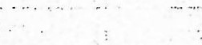 | IPD Nurse   | 02-06-2024 07:54  
 | Notes | Type | Added By | User Type |  | Added On
4 | PATIENT SLEPT TNTERMITTENTLY DUE TO HER  CONDITION, AWAKE THIS MANE WITH NO NEW  COMPLANS LODGED. ASSISTED WITH PERSONAL  HYGŒNE, BED LNEN STRAIGTHENED. VITAL SIGNS CHECKED AND RECORDED PER LHIMS, DUE  NEDICATIONS ADMNISTERED PER CHART. ALL NEEDED NURSNG CARE RENDERED, PATIENT  REASSURED AND YLADE COMFORTABLE IN  BED,AWAITING MOs REVIEW THIS MORMNG | Nurse Notes | Tetileonia Bosomtwe | TPD Nurse |  | 02-06„2024 07:26
5 | AT 10PM, VITAL SIGNS CHECKED AND RECORDED,  PATIENT IS MADE COMFORTABLE IN BED AND REASSURED. | Nurse Notes | Tetileonia Bosomtwe | IPD Nurse |  | 01-06-2024 22:28
6 | AT 1 OPM, VITAL SIGNS CHECKED AND RECORDED,  PATIENT IS MADE CONFORTABLE IN BED AND  REASSURED. | Nurse Notes | Tetileonia Bosomtwe | IPD Nurse |  | 01-06-2024 22:28
7 | PATIENT SLEPT WELL NOCTE AWAKE THIS MANE  WITH NO NEW COMPLANS LODGED.ASSISTED WITH PERSONAL HYGIENE, BED LINEN STRAIGTHENED.  VITAL SIGNS CHECKED AND RECORDED PER LHIMS,  DUE MEDICATIONS ADMINISTERED PER CHART. ALL NEEDED NURSING CARE RENDERED, PATIENT  REASSURED AND MADE COMFORTABLE IN BED AND  ENCOURAGED TO VERBALIZE CONCERNS. AWAITING MOs REVIEW THIS MORNNG. | Nurse Notes | Tetileonia Bosomtwe | IPD Nurse |  | 01-06-2024 06:56
8 | AT 8: IOPMPATIENTS CONDITION WAS SEEN TO BE  DROWSY, RBS CHCEKED RECORDED 9.8., REFUSED BP  MONITORING. | Nurse Notes | Abigail Asor Duah | IPD Nurse |  | 31-05-2024 22: 15
9 | PATIENT WAS TluANS MO THE WARD TFROUGH EMERGENCY UNIT ON A STRECTCHER ACCOIOANIED  BY A NURSE. A BED WAS OFFERED AND VITAL SIGNS  CHECKED AND RECORDED AS  AND SP02-97%. ON OBSERVATION,PATŒNT IS  NŒNTALLY CHALLENGED,POOR HYDRATION AND  DISORIENTED. SHE IS MANAGED ON  FOLLOWING NŒDICATIONS :CAP DICLOFENAC 75MG  BD X 5,TAB AMOXICLAV 625MG BD X 5,SC CLEXANE 40MG DLY X 2 AND IVF N/S $ DNS 1 LITRE. ALL DRUGS COLLECTED AND WERE INTACT. PATIENT IS UNDER  CLOSE MONITORNG | Nurse Notes | Ernestina Darfour  Obenewah   | Nurse Prescriber |  | 31-05-2024 16:14
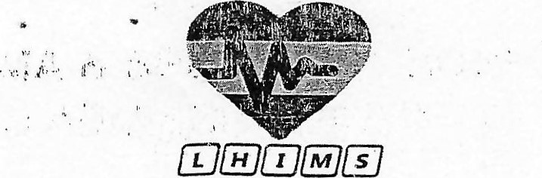
a 
EHEåITtÐRVSOlUltONK:
Admission Chief Complaint
Chief Complaint
No admission chief complaint available
Additional Services
 | Additional Procedure | Rate Type | Frcm Date | From Time | To Date | To Time | Notes
 |  |  | No additional service available
Diagnosis


17:00:46

 | Type | Code | Description | Code Status | Date
1 | ICDIO Code | F29.OO | Unspecified nonorganic psychosis | New
2 | ICDIO Code | G89.11 | Acute pain due to trauma | Recurring | 29-05-2024
3 | DRG Code | ZOOM02A | Detention for Observation and Treatment - Adult | New | 31-05-2024
Operations
 | Surgery | Date | OT | Timing | Chief Surgeon | Anesthetist
 |  |  | No operation available
Diet
 | Menu Type |  | Menu Name | From Date | To Date
 |  |  | No diet available
Clinical Notes
Sr.N0. |  | Note
 |  |  | No Notes Available


4.
!Jf'4hVVr
)atient raşi. VVLAO i- AAf-iöI^{j} ü#ğ
«tıet'it (JNRüVC)i^{k}j 45 'î Car(ş)
;ge. 45 Y'e.ar('ş) Veıght jex.• Fetmaie paın ı.raşııri,îl
Jnit ANE
t ANİF: P & Time: 29-05-2024 17:10
Fal teni: fû.^{c}jcribeı•s marna: F.:.VANs
Tİrne• 1 7 • 37
fi [h:
İR 'dile, Total
70!ül ty
10
0.00
Q. (.İQ
16.00
Iy
l"il ["0 |S Chior:de Injection 14.00
2/TıL ili friİeutiUl ı,D f..sodiurn il üCtİnn '50 MG, Stat 'l
[2 ğY(sjl0 iniusiürı, 50CJ Ml.„
T ı Day(s)]
[Z Jnjesc.tk-jfl, n-;ıg 'ml in 6 00 yıl [Dıazeparn ifijecıiorii 5:xtrage in Sadium 12, fi in 2 5 in 2 mlir ravent)ııs in
L yj(s'j!S jcliurn Chlor:d3 Intravenous
Ir •usıorı, 5⁰/0 in (19”
Tr-jta! (GHS )5 0, 9 ⁹/11 ('5QOnıİj. IAlSİüf)
Dit')üüurıt (GI-LS )5 0 BDS ı
Total AiTi0Lınt İA JTI..TETANUS SERUM
T ETAN(JS SERUM, 1500 j. u.
PBid )
C 3Y(ü)]
E & o.E CHECKEL) Balence LAWRENCIA OSEI
Detaıis.
L Irıjeclic;i') T^{i}.l) rngK3mi 3„oo
[l iülDfeş;ac / b fiıg/31•nll
Payrnerıi 7 ı Day(s)]
l. (20 mg. 75 ment Data Found MG EL).S
+ (..llâ.ij'idlEI/'iİQ,
I!' 1.29
ı MG.
İ 'S mg. 125ÜMiJ

[.ilâİ Hf..J.frj
I.)
DAILY WARD S WARD 31.
Office NÔt | Admission  N[àme
Age
Office: ward Age |
No
P'revå.ous,
fisfe:rŠ• o,úL• Floor Pâftents
Mec JIHos•pitTh
Recent Stregs•
Coping Mechanisms • Support System:
Calm: Yes a No Anxious: Yesa No
 | Religion•  Tobacco use; Yes a No  Drug Use: YesEJ No Cl | Specify
F of-der No ward.
Gender M n (.)c.cupauon.
TCI No..
Time o 'Idmission:
 | Alcohol Use Yesa Noa
 | Oriented: Person  Sedated | Place a Alertn | Time a  Restless
e. Widowed Separated C] Spoken.
Lethargica Comatose=
Pupils: Equalg^{Z}UnequaIC] Reactivea Sluggish
Extremity Strenght: Equal Unequal a
Ambulance a Stretcher  A JRbCJiatory with Aid CA Wheel chair | Speech: Cleara Slurred = Other
 | Normal ROM of Extremities: Yes |  | No
 |  | LA
Notined | Paralysis:
Provt.storžaž | Contractures: | a | a
Name Adrrllttiñg Nurse: | Joint Swelling:  Pain:  Paresis:
Type of Paueat• NI IIS Paying  Others.  Source of 1 11 f'ormation•. Patient C] Other  Unable to obtain History | Others: (Specify)
 | Püt,Orn: Even | Uneven | Shallow
ward Yes | Dyspnea | Other
Orœntattorl to stati Yes | .Byeath Sounds: Clear Unclear |  | Other
explained Yes Non | Secretions: None Others
Yes  • Yes | Cough: None Productive a Drya

explained
I ons of ward: Yes
FBS.
Weight
CVA
Respiration Disease
Others
Type
t •C'àlrnent
Pu!Še Pacemaker | Regular | Irregular CT-I
Strong | Weak | 'Ihreadya
Edema: Abesent  Site• | Present
Nature: Pitting (Z) | Non-Pitting
Perfusion: Warm C] Dry Diaphoratie. cool Hot
Pain a Area
oral Dry C] Moist Co/ Dysphagia C]
Otther
Bowel( Swužflds; Present Absentn Hypo Active
Hyper Active
Abdomen: soft e-
Diarrhoea Conngripation
Fecal Incontinence Cu^{i} Hemorrhoids C]
Pain
Retentio.n CT-I .Hematuría ysuria Incontiw,ence c-j l..esions
Catheter Yes n No
Othev•s•

fit'.
Pallor El Jaundice Bleached Skin Wounds Cl Rashes[ll
Others.
Well NourishedCJ Emaciated
Other's Specify
Appetite: Good Poo ru Fair
Meal Pattern: Once o Twice D Thrice
Four or more
Diet: Normal O^{x} Vegan Vegetarian C]
Low Salt Low Fat C) Low Carbs
(Pressure sore screening criteria) Total = Turgor (adequate elasticity, skin warm and moist)
Poor turgor, skin cold and dry
Areas molted, red and Denuded
Existing skin ulcerILesion
Bowel and Bladder Control: Total= czsn
Always able to ask for bedpan
Incontinence of urine incontinence of Feces
Total Incontinence
Rehabilitative State: Totai=
Fuliy Ambulatory
Arnbulatory with Assistance
Chair to Bed Arnbutatory Only
Confined to Bed immobile in Bed
TICK
PARAMETR SCORE
Eye Opening
Spontaneous
Response to speech
Response to pain
1_ No response
Verbal Response
Oriented and Appropriate
Disoriented and Confused
PROBLEMS IDENTIFIED
No response
Best Motor Response
Obeys commands
Localizes pain
Withdraws from pain
Flexor response
Extensor response
No response
TOTAL
INVESTIGATIONS

IV...BC
2. ..Ev.+4...o.oss.„.n^{p}iNQck03
TREATMENT
1 , 7,Spo
STRENGTHS IDENTIFIED
CARE PLAN GOAL
• (3.0.
NURSING ORDERS
it.tskll.t
V.-Ä-,.
. òteea
NU SING INTERVENTIONS
inappropriate words
Incomprehensible sounds
EVALUATION
5.
NURSE NAME:..
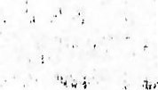
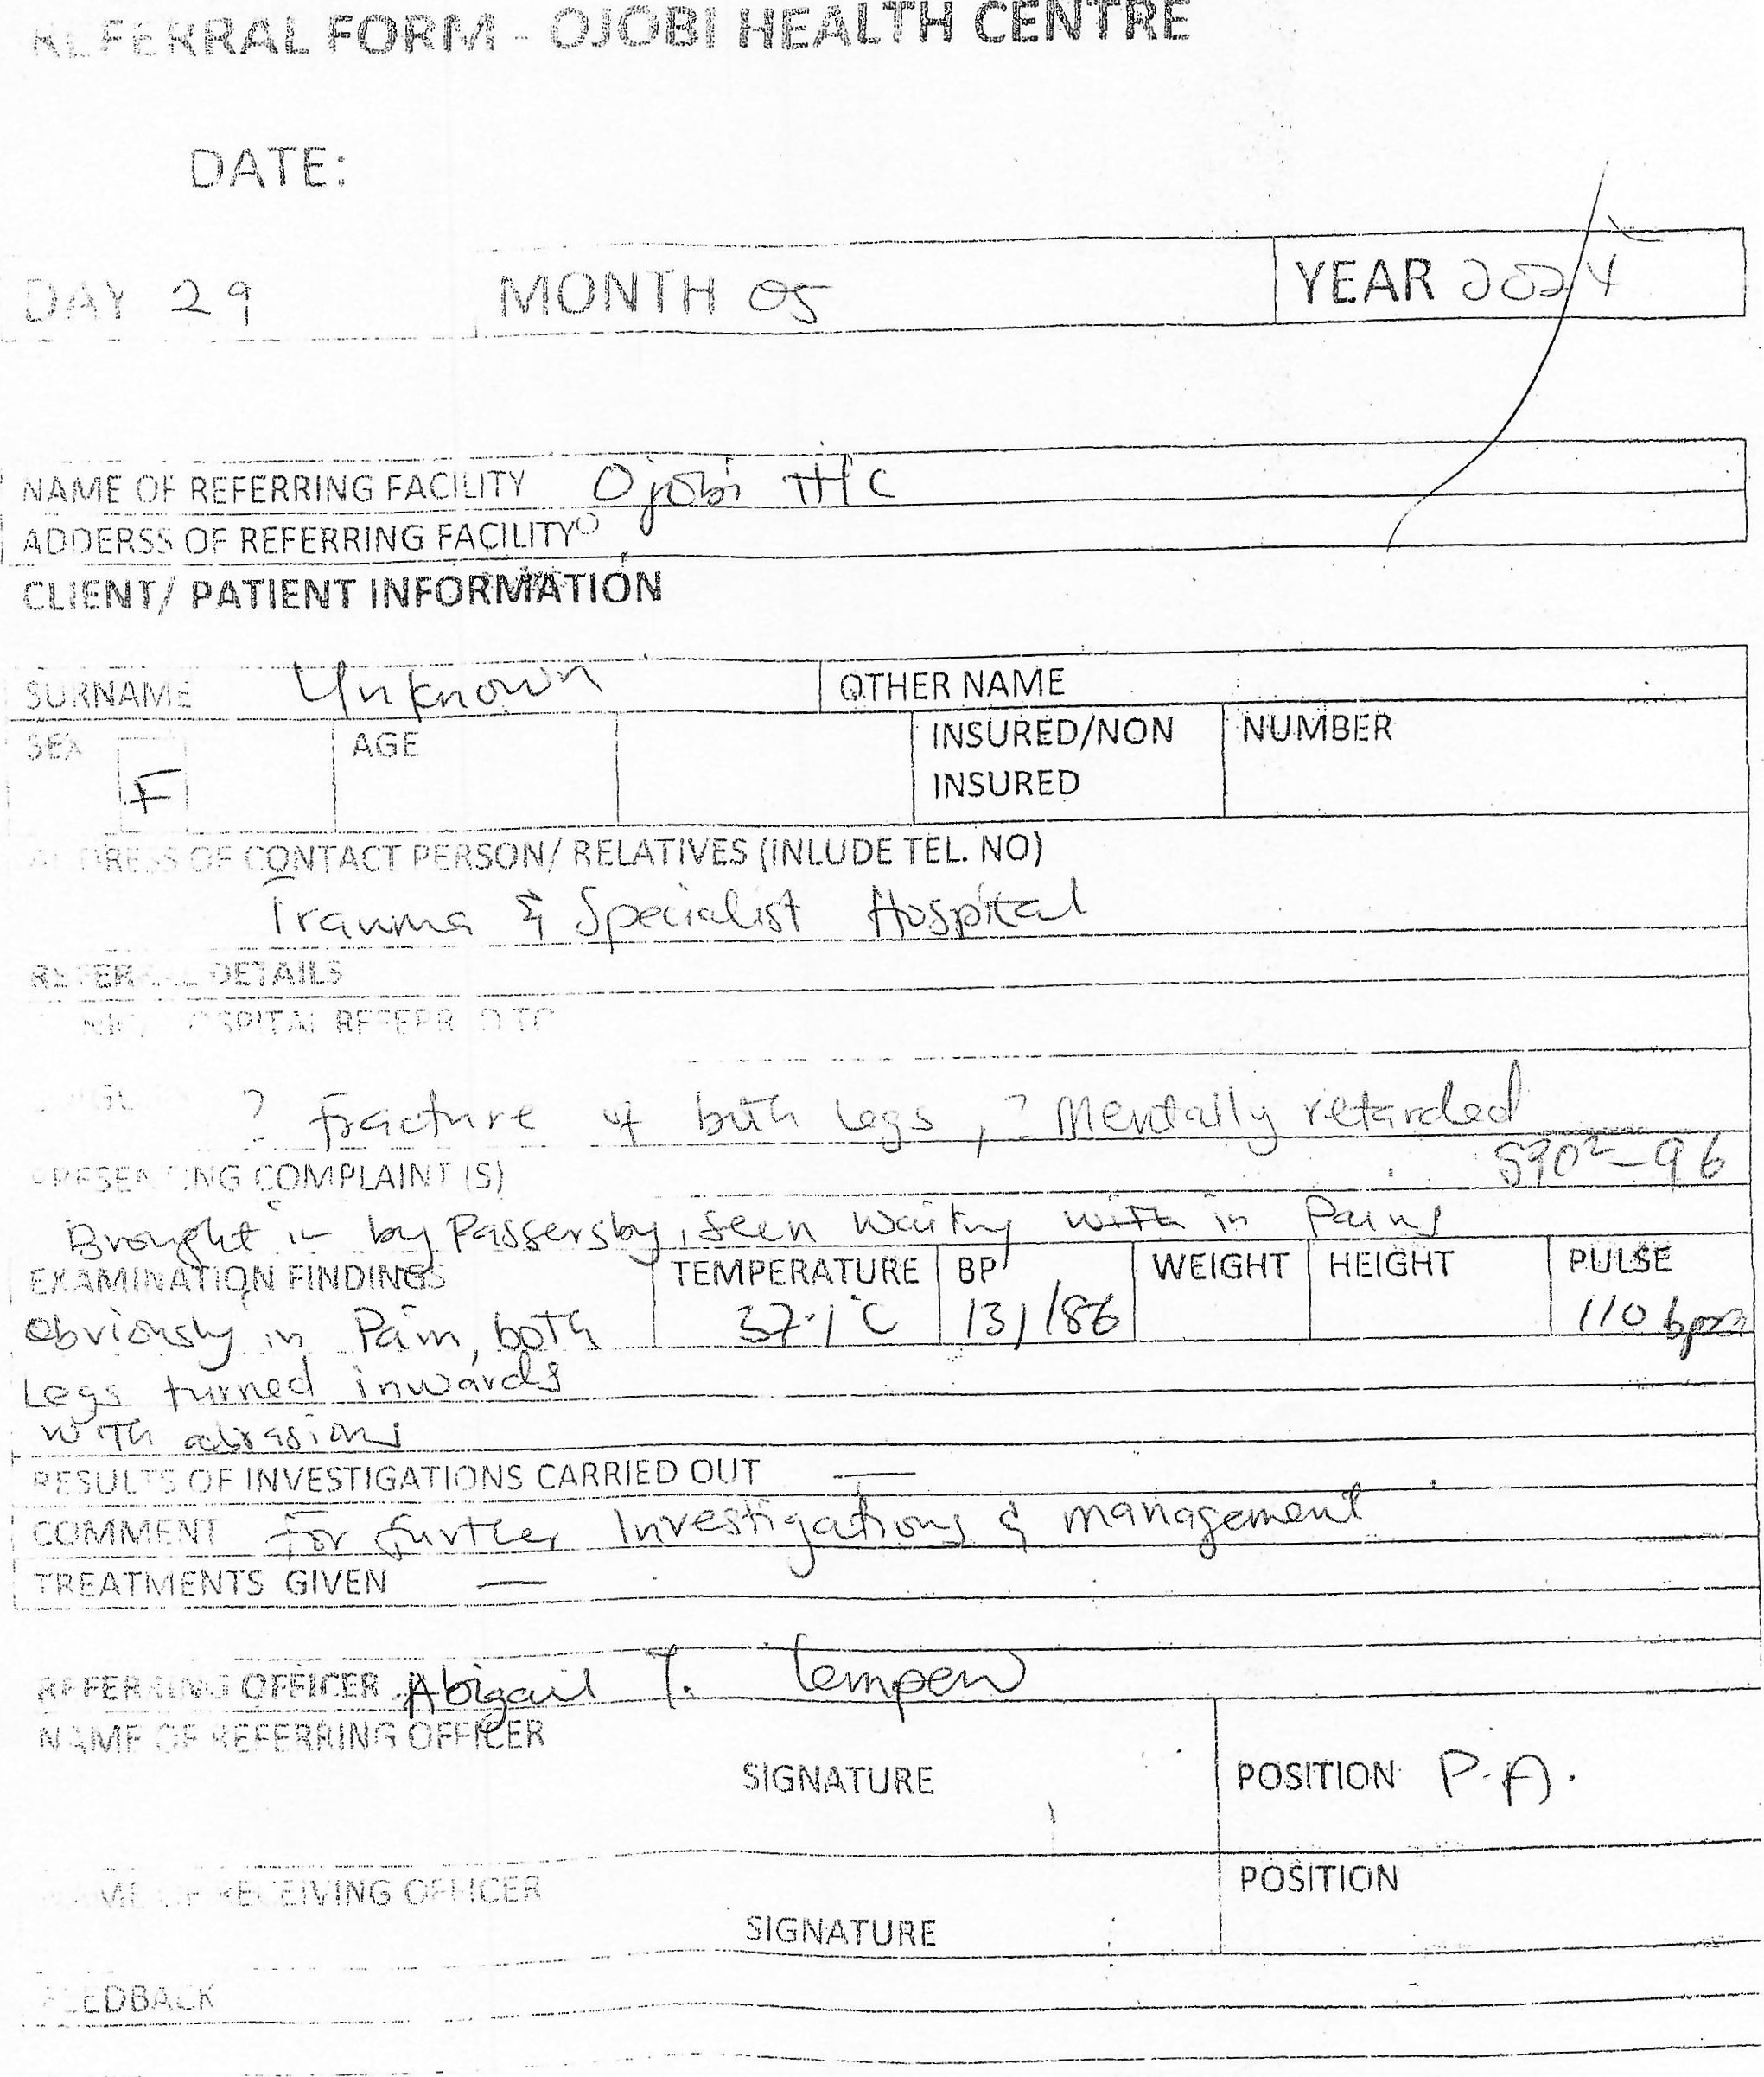
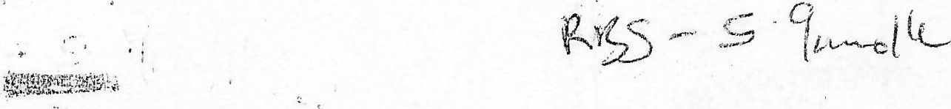
RSB SP02e

TRAUMA SPECIALIST HOSPITAL
WINNEBA
ACCIDENT AND EMERGENCY DIRECTORATE
TRIAGE SHÉET
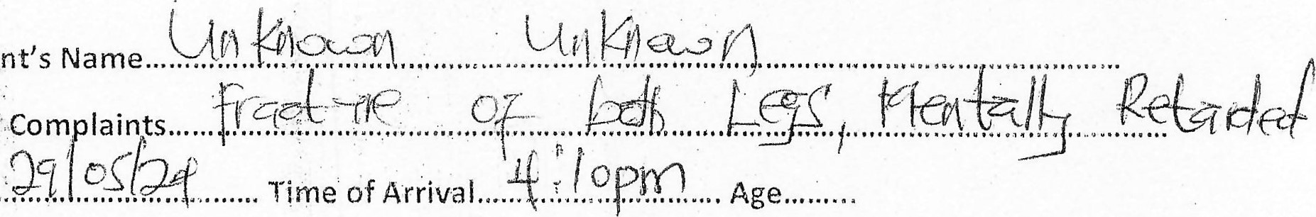
Patient's
Chief
Date.....,
sex: M / F
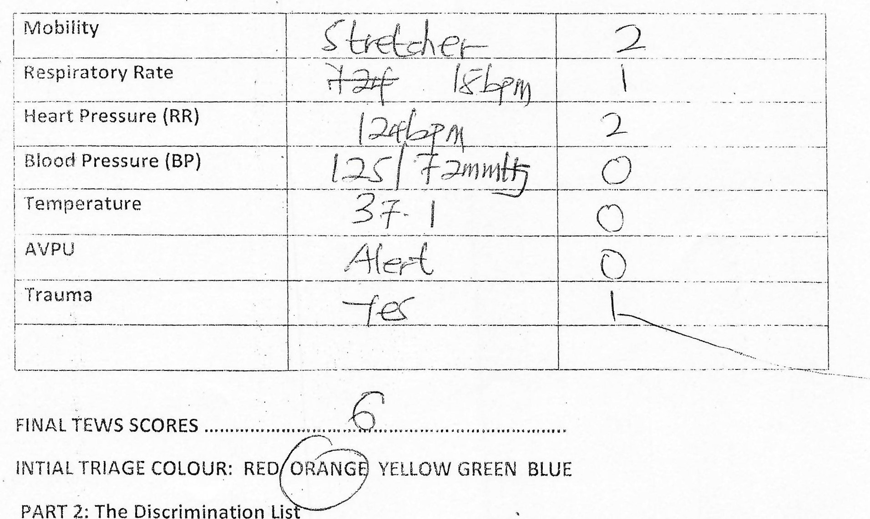
PART
2:
The
Discrimination
Lis
Part
1:
Triage
Early
Warning
Score
(TEWS)
- Does the patient need to be triage to a higher our on the discriminator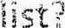
YES NO
- What was the discriminator?
PART 3: FINAL TRIAGE COLOUR: RED ORANG YELLOW GREEEN BLUE
1.
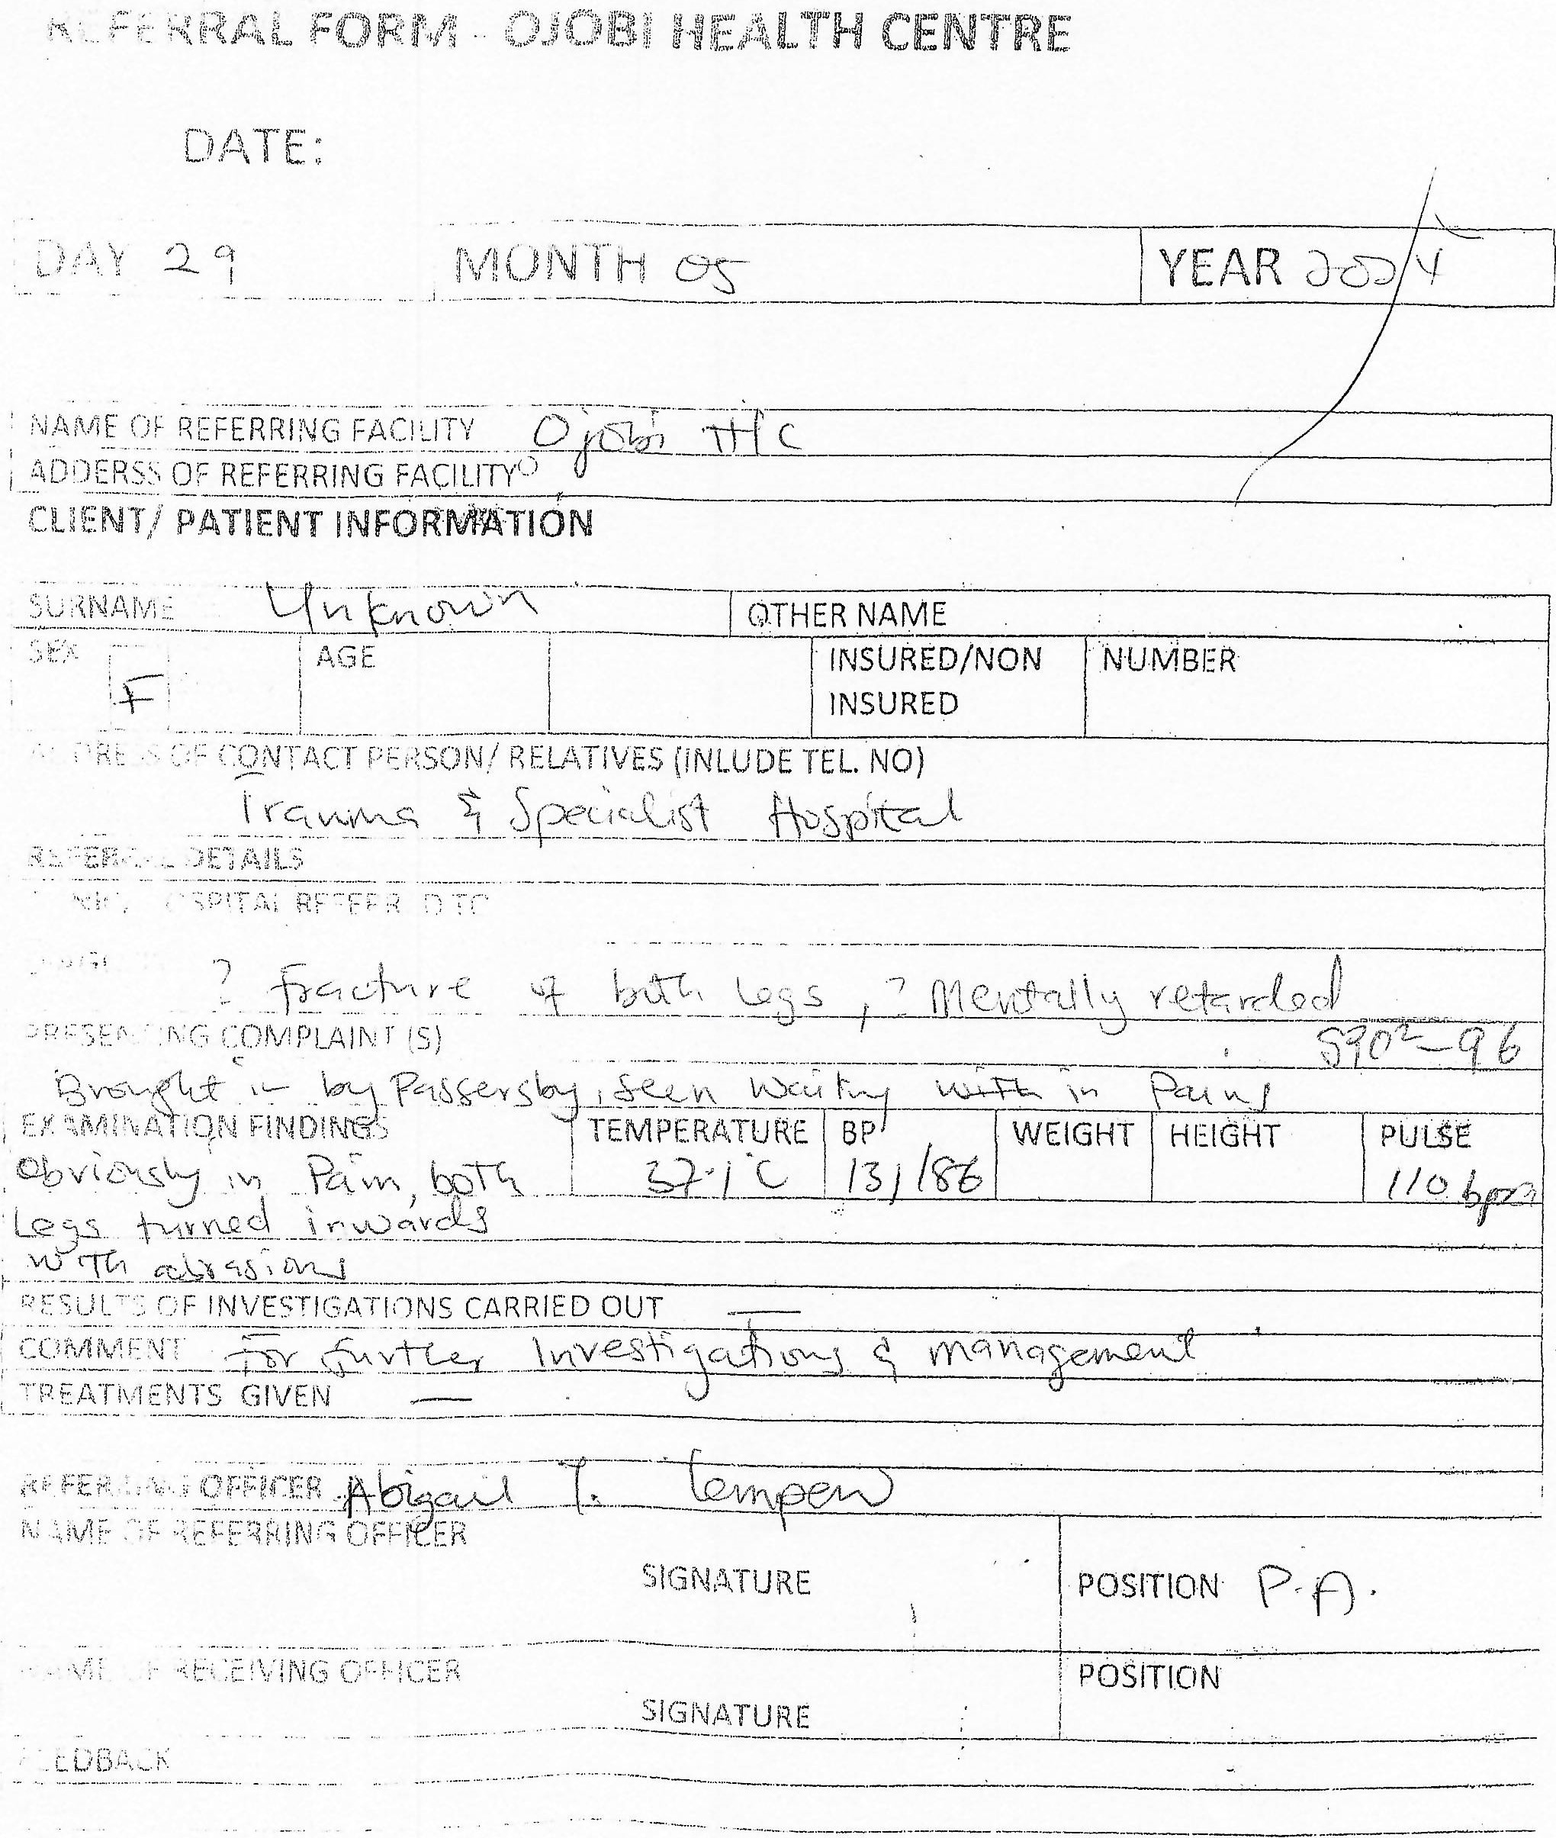
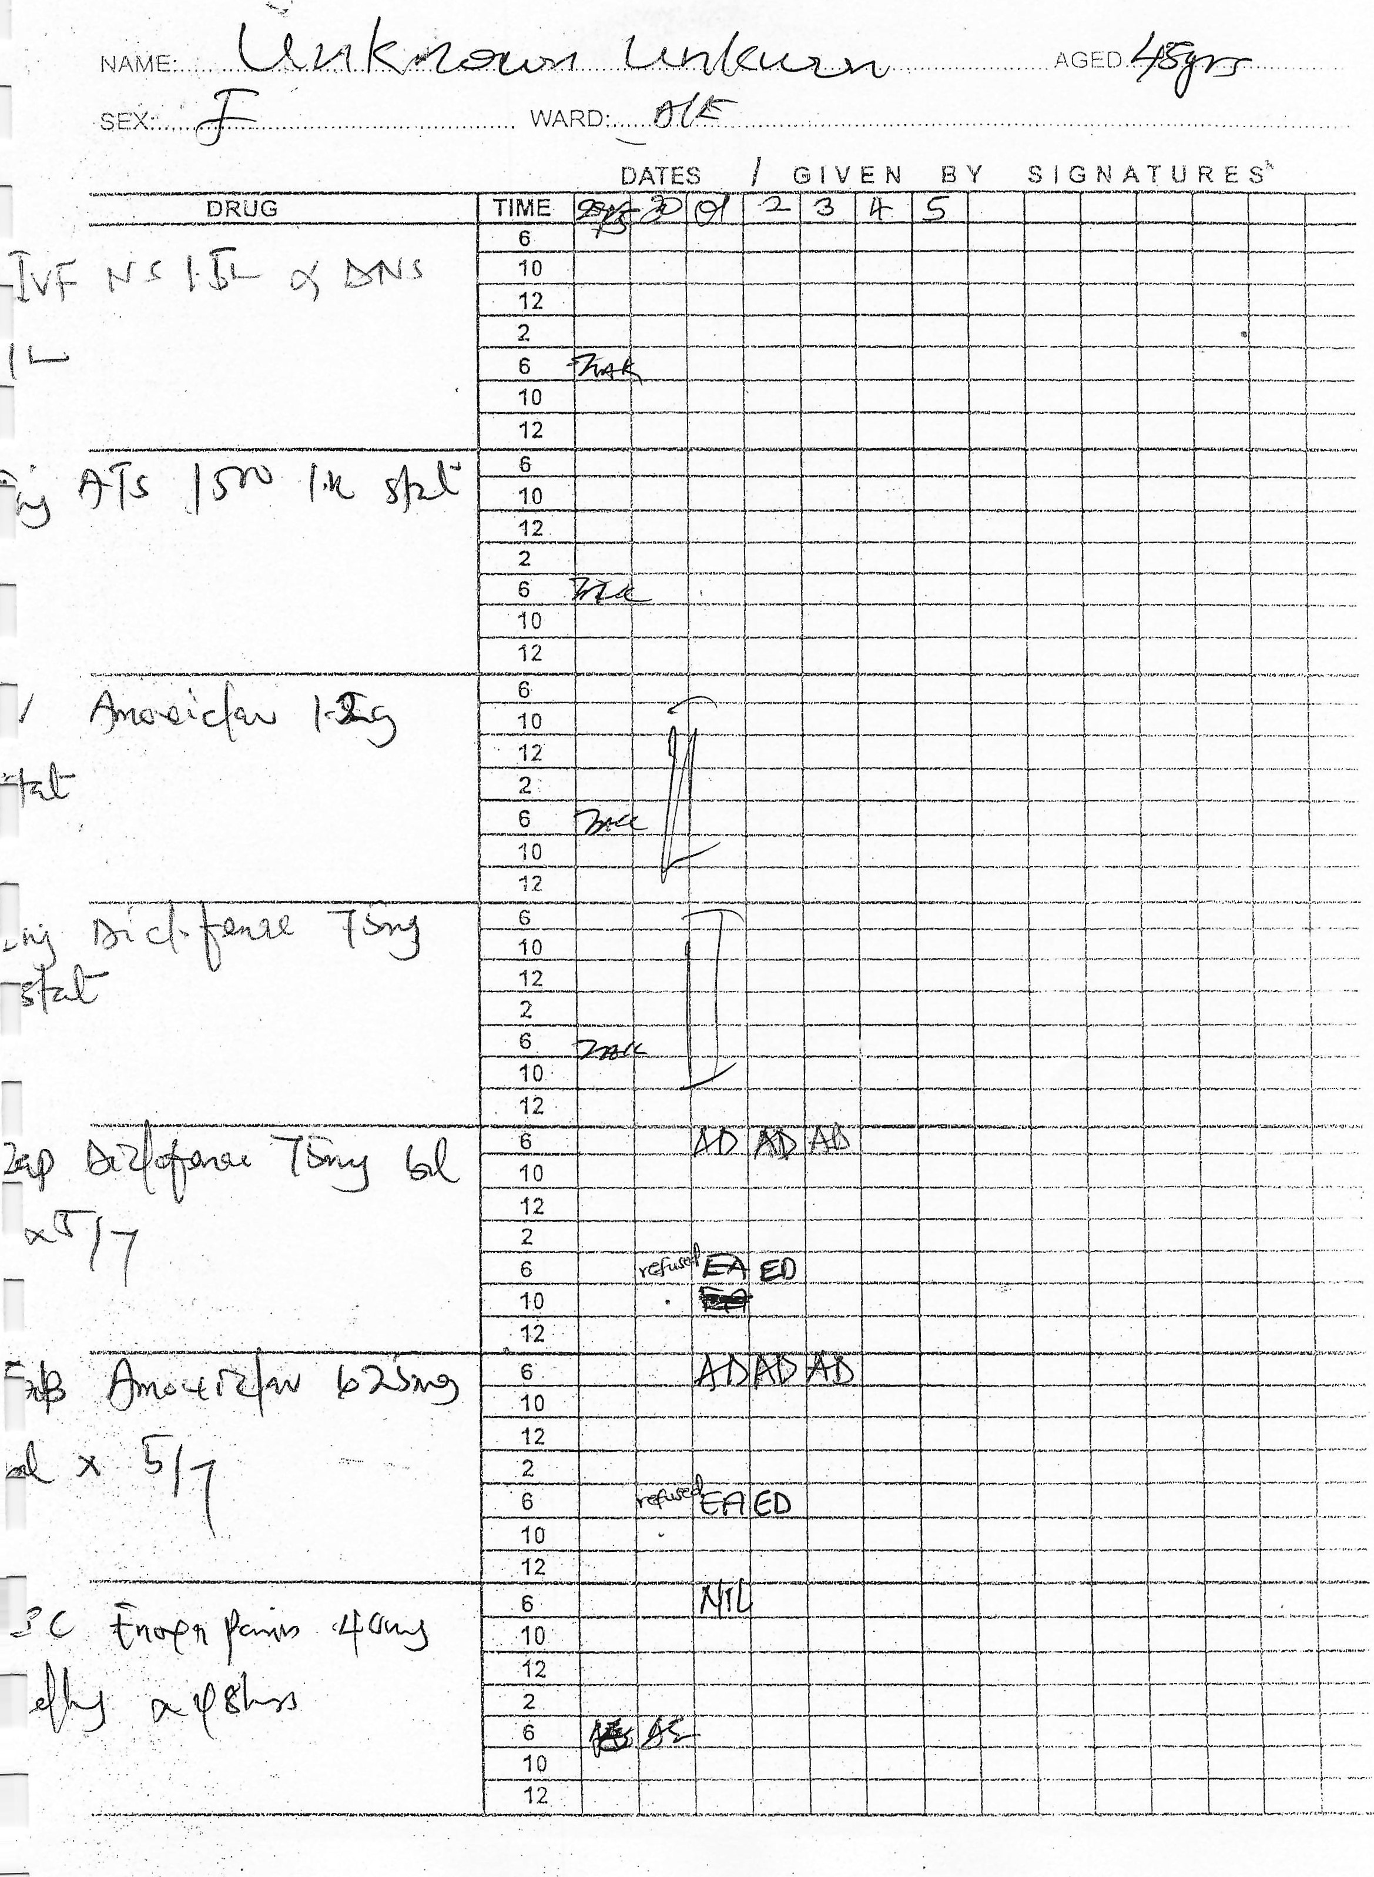
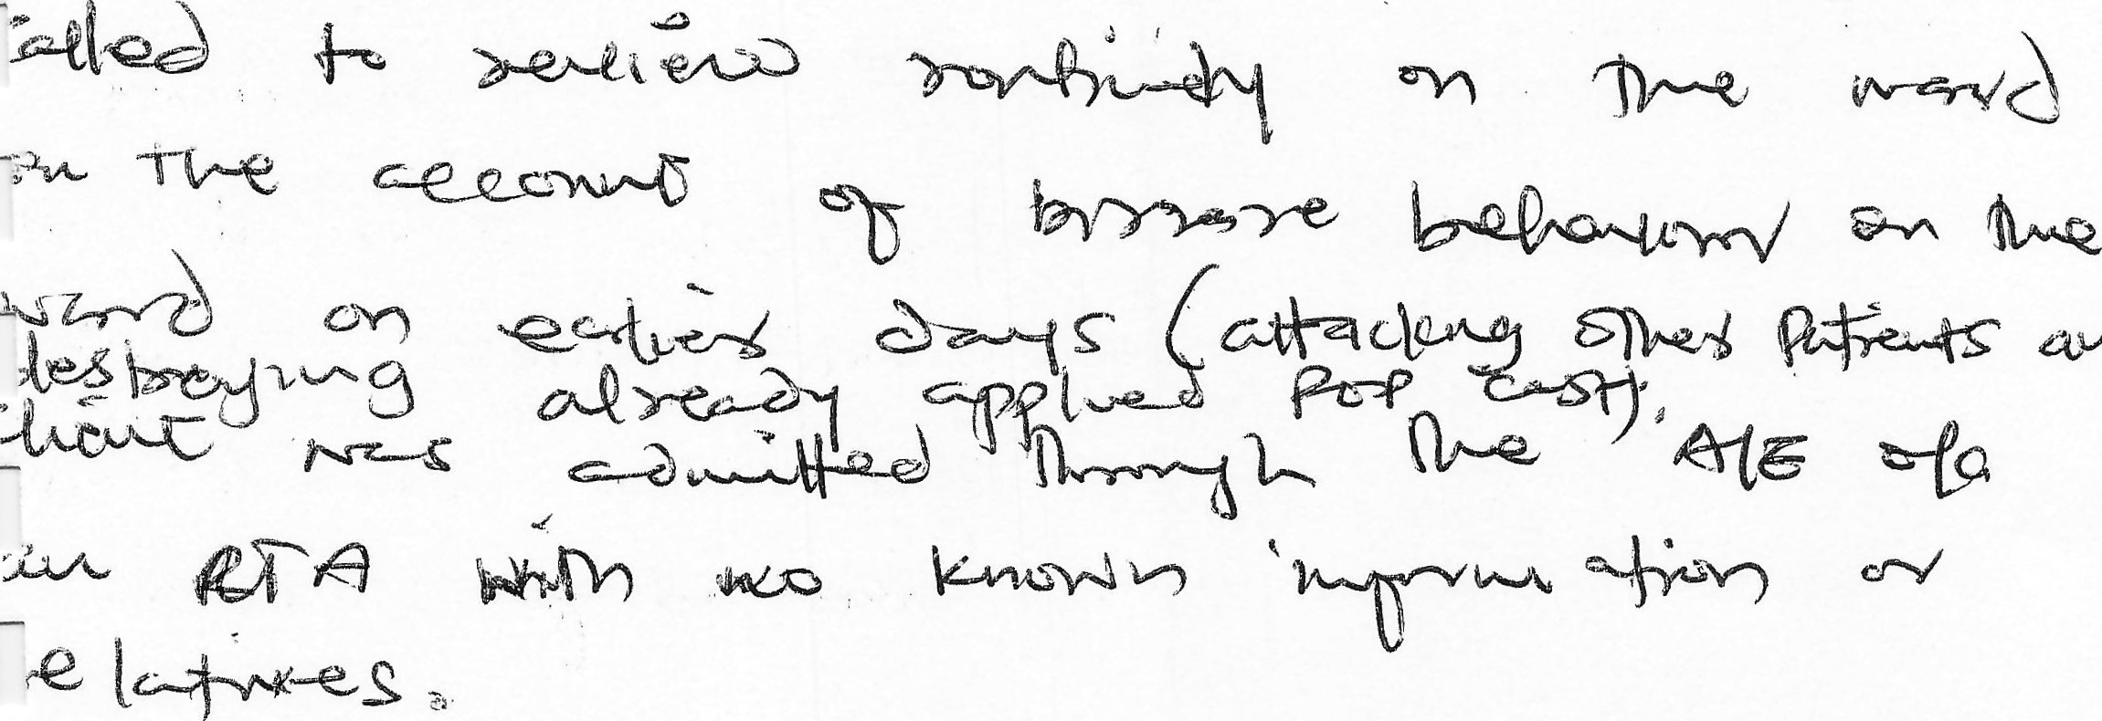
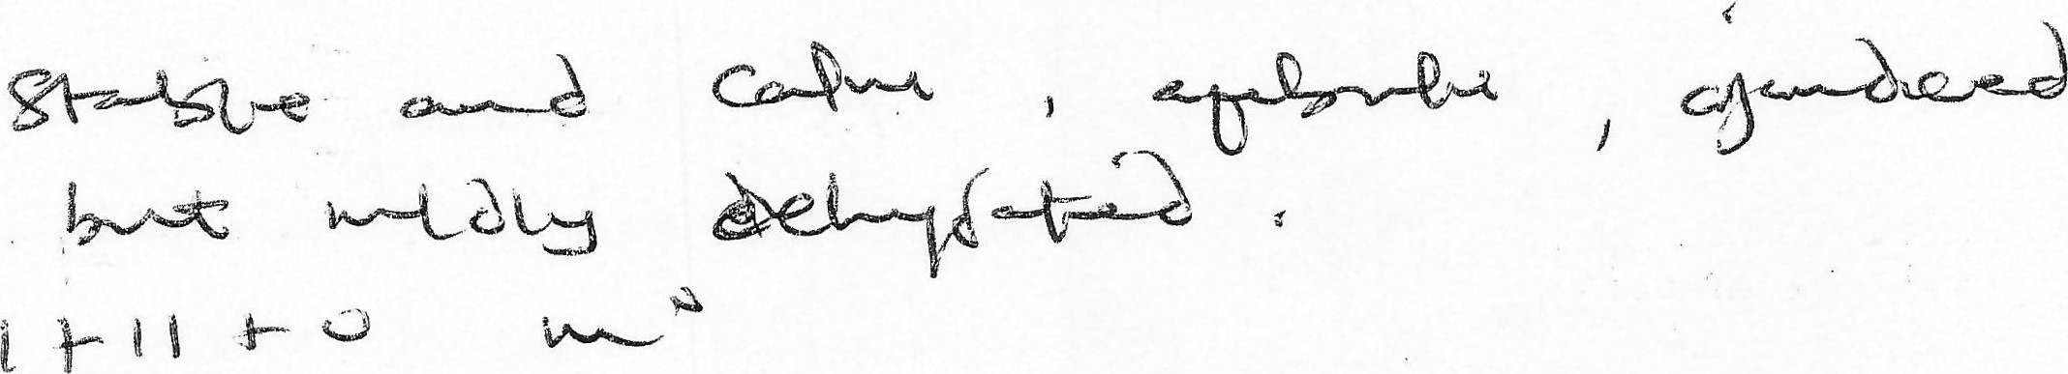

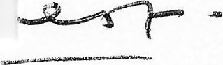c-lc
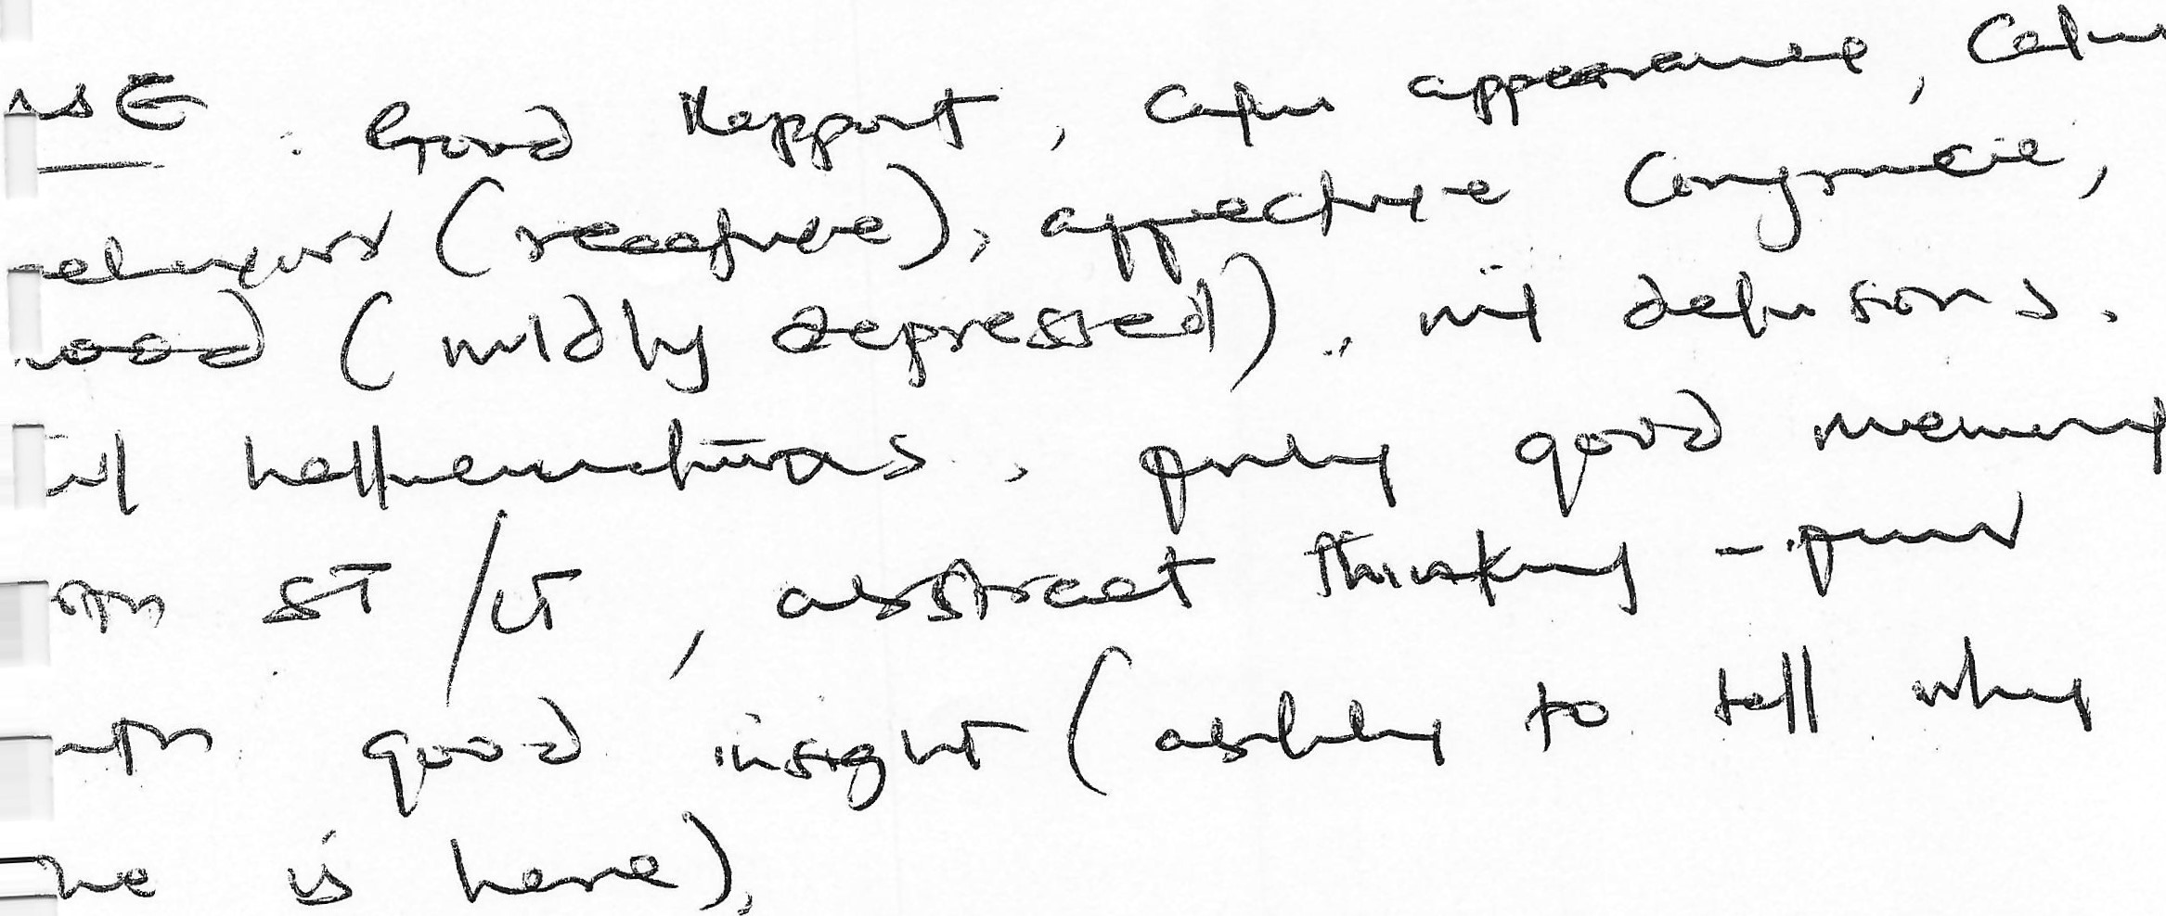

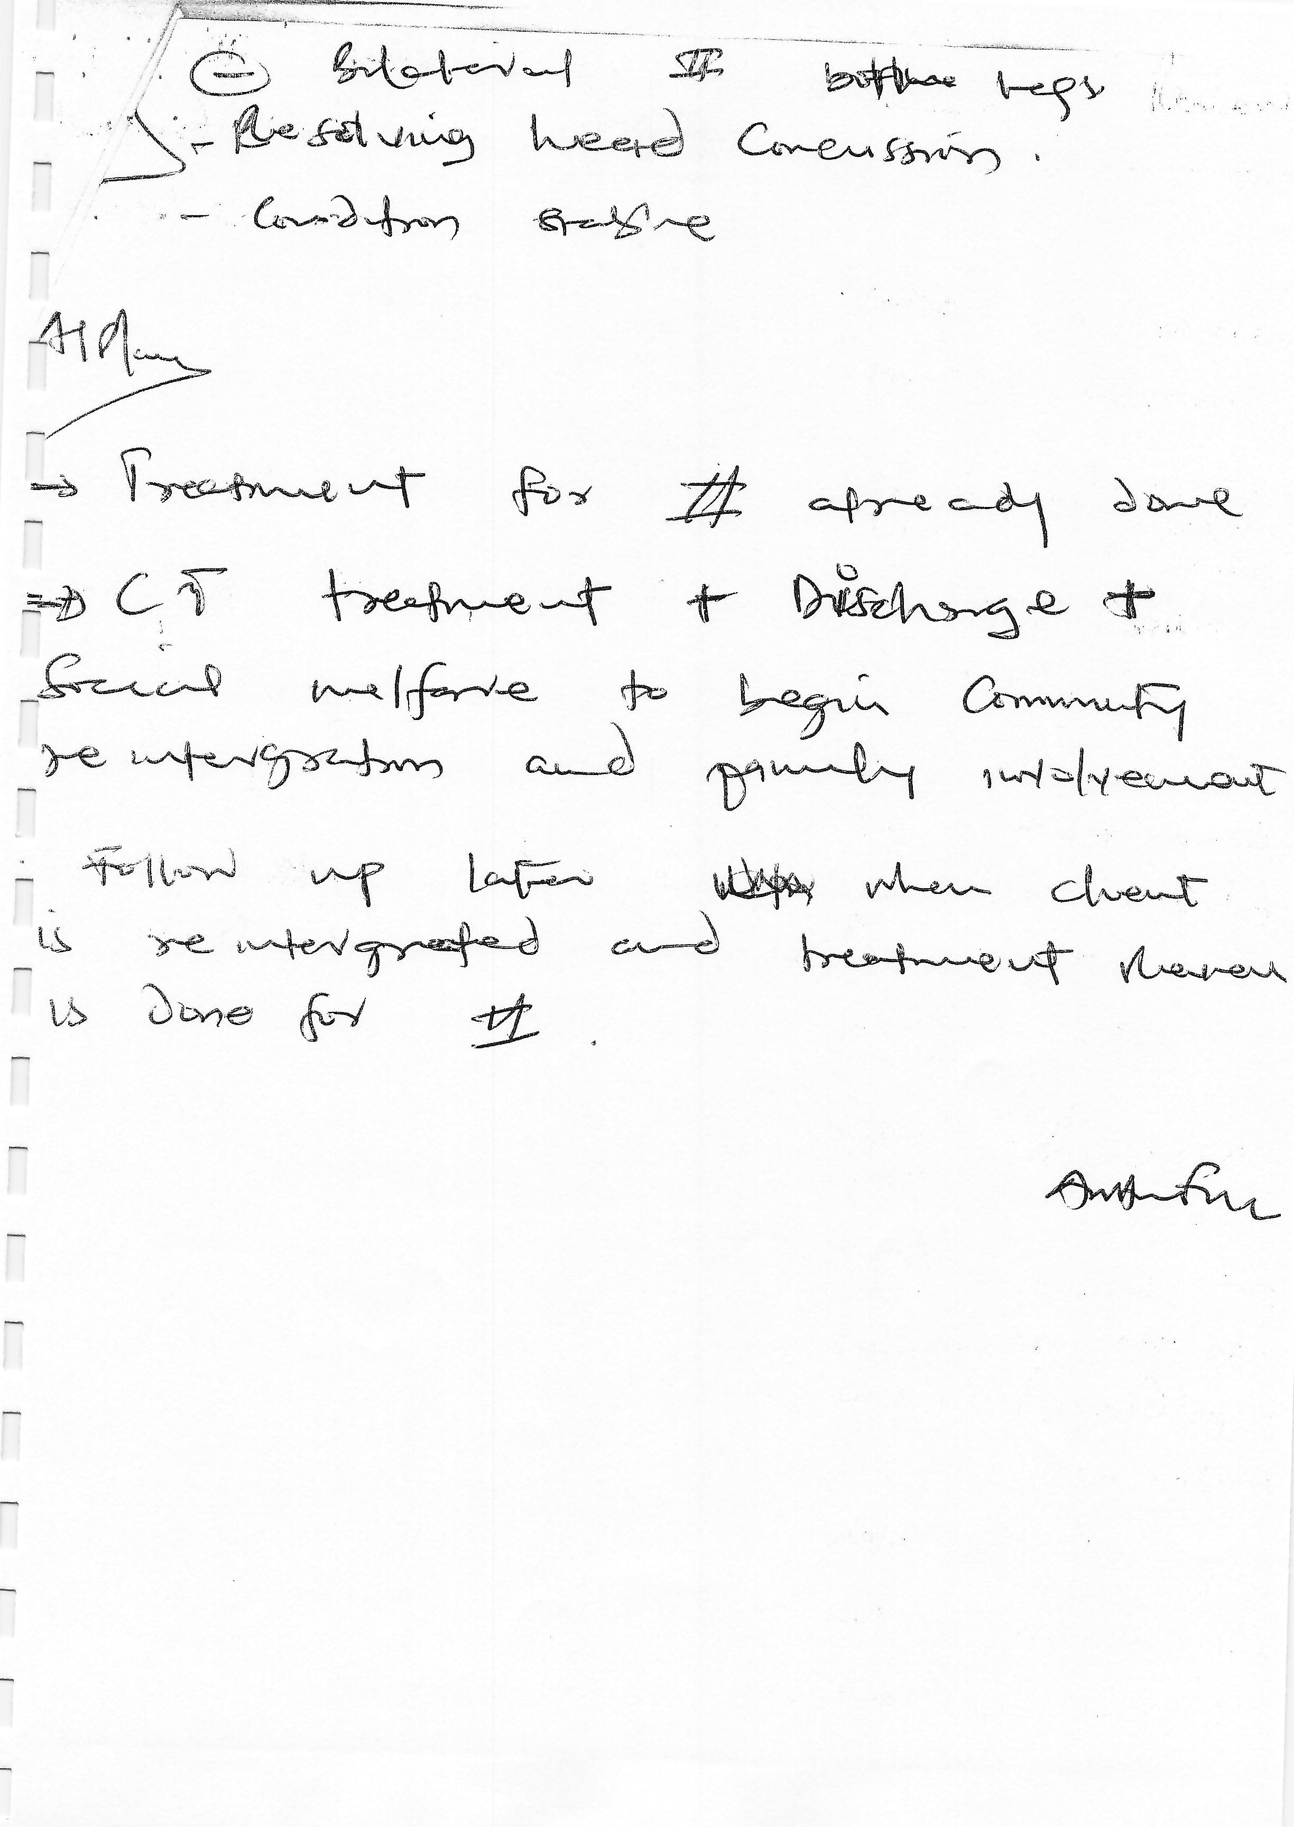

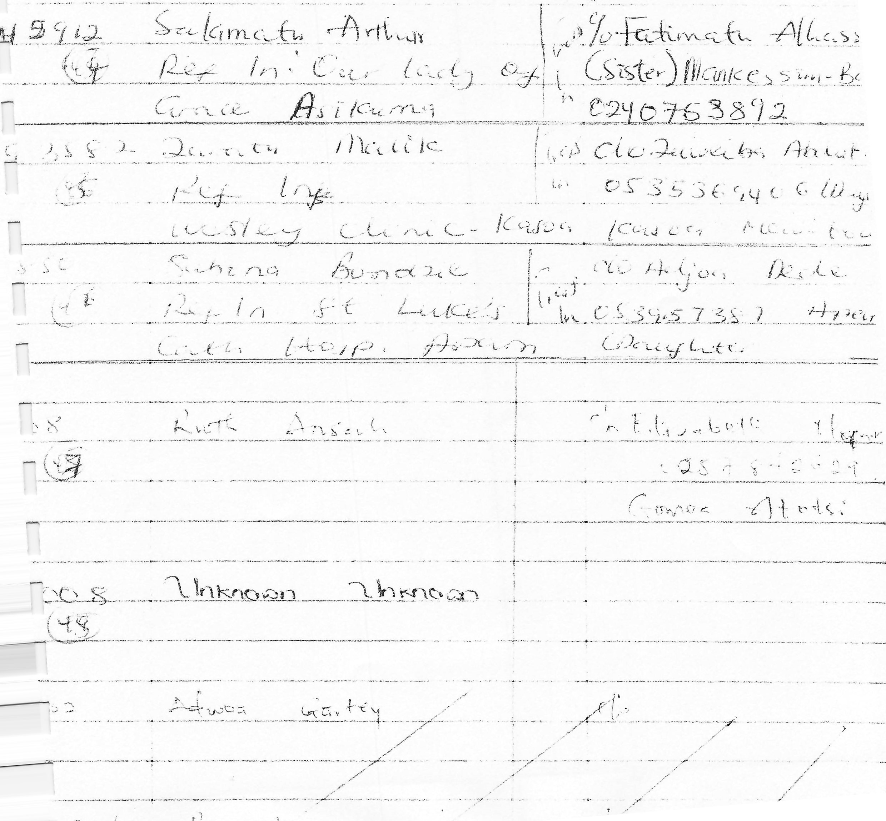
A m ①配And

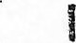 P. No. Name Address
So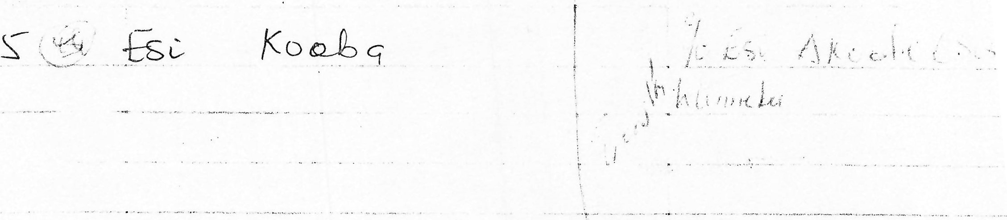
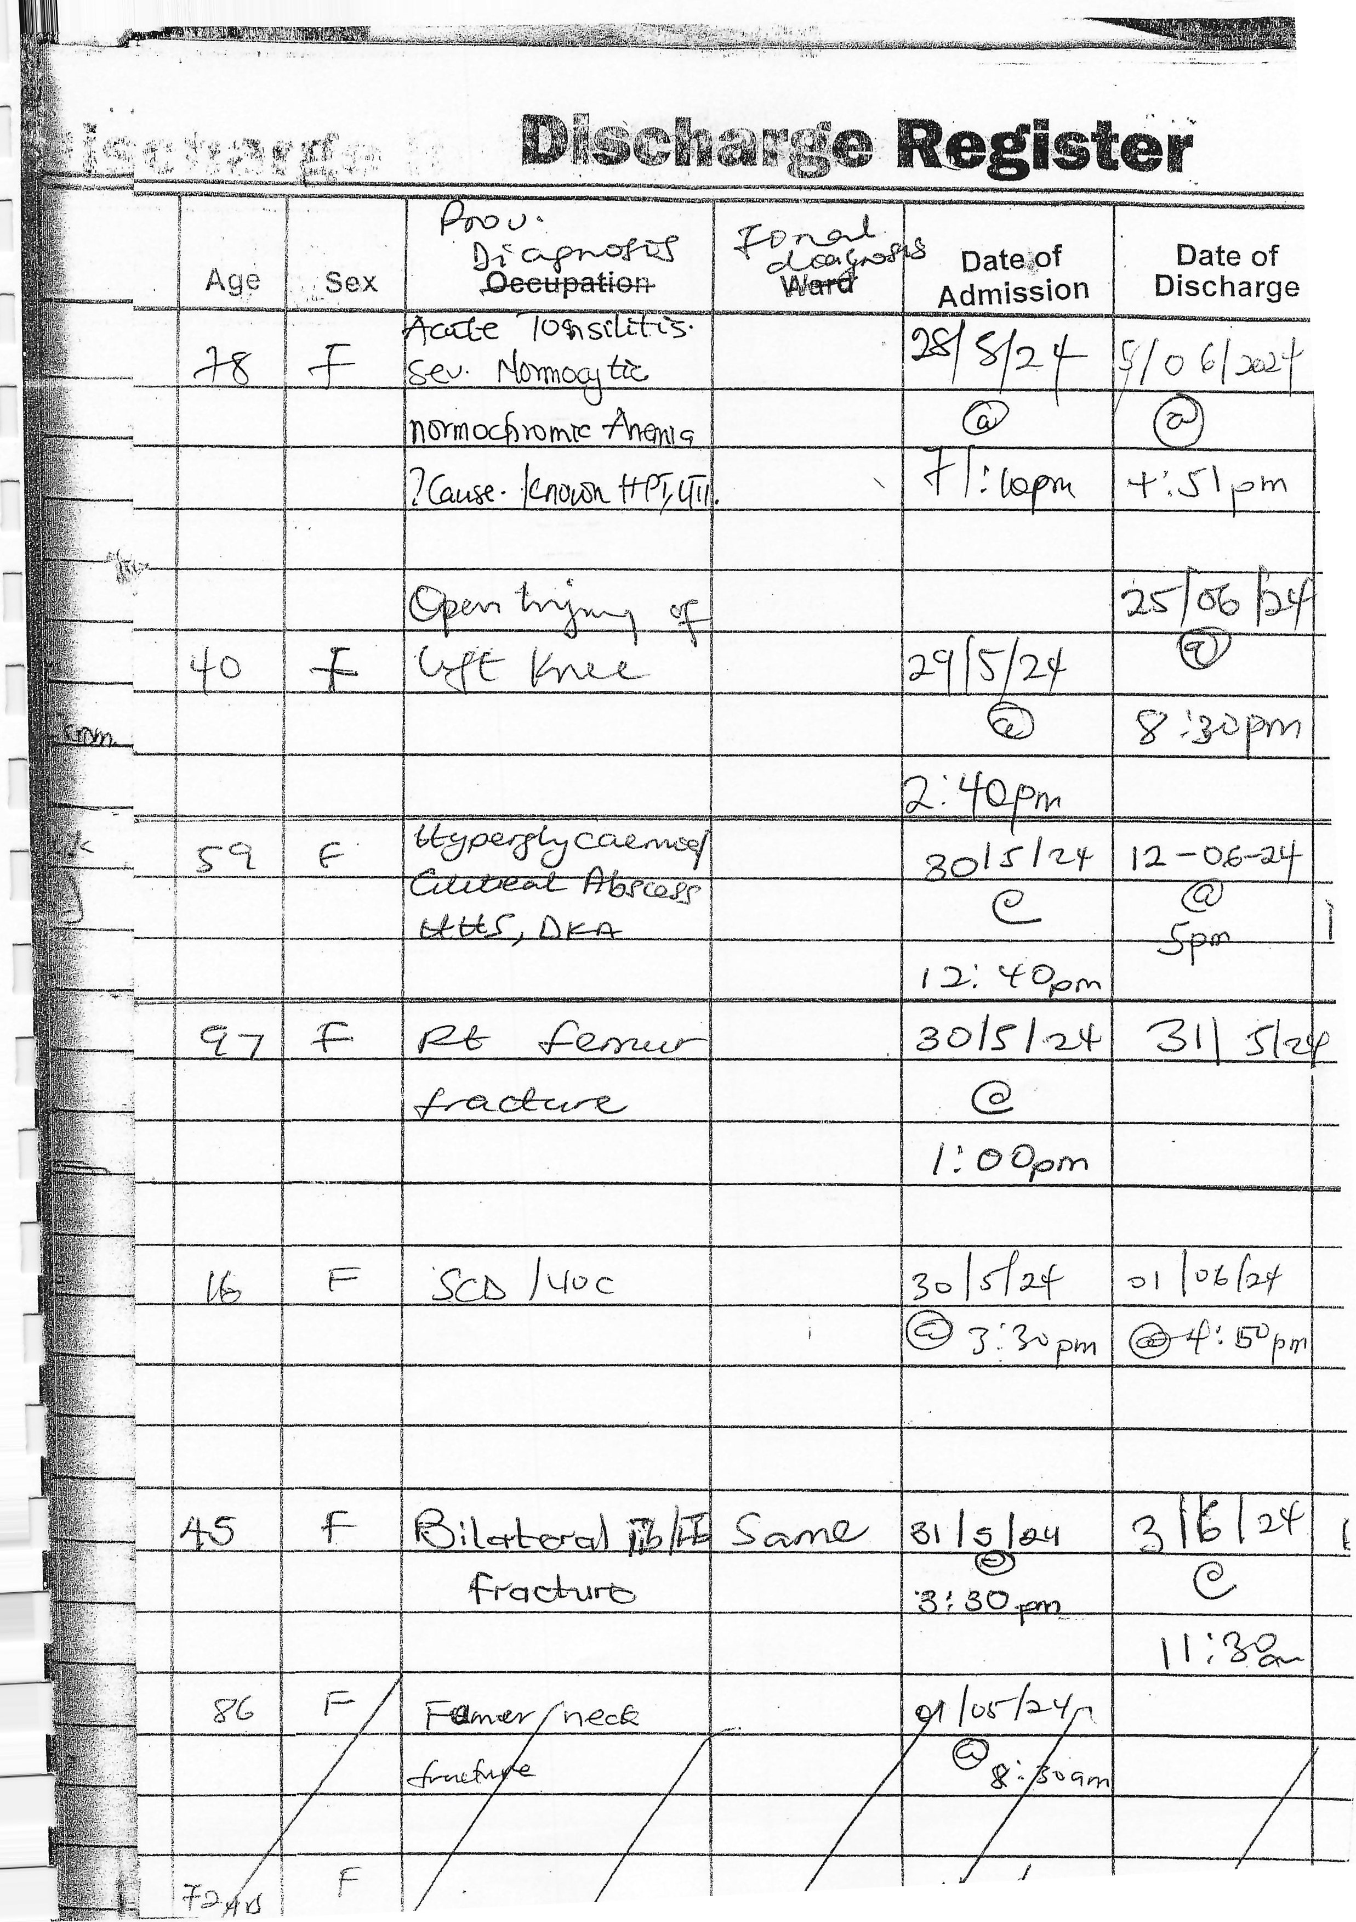
を物し明ノ0れ/つ77
ー・, ,を駟
・
・
立ー 。 千、刀06 2ユ 津乙肉ラ コ弔
朝 を 、
、
「顰
22 6 3〒( ) - /羽
ト し: ま嶐
o自1. 当~ 。 。3 Ⅱ ) 0 下い
7認苞 月如气十
.
は 34」%气g3
」
こ 4 籍い
い、、 2「ス切もし「次」」に は自厚ル.し气島
・
県
森
%了ププ/ It:D ゾ日9ー0目8カ%

%。。必い艇響 ~
よ
ゞ
: ジ 材ヾ をュ 可
~
・ !
れ
を、
・鸞は
レ
・いい 07 ー 0 ~
を 3 【了 ' に
評は レ 引嘯 (
, ・ 0 /売仁
- も
み
当 ツを ロい。・0ハさい・~
を ・い
いは
い・ 0 、
- い
、当こ
二、
「
: 、に鱧は
/
2
・ り芻】0 を
) い・* を
はいッ
一、ー
0
・
、・い 33
二
いー 4 、に
いに
れ当、 0 りしをいドい当計
、当
書当? .を 。 4・い第
~・対い報
ぎ
はを氈3を叫を:、 を=。を孕, を対物詈 を:げい=忘、・
明書

を
、
一鸞
朝 なミ,1こ
.
0
ア
彎は
顰当ツい
~ 3・三:な
い・名 、物,可な・
・こを一
~
!にま 0 (ノ
を (.
キ謇
23 匚しこ廴。之れ、トー・い。-、。&
・な藜・・、ご、
。法岩彎当
受ざ :
、ト
い寸 方、,・拿、ユハ
・な
鰐村尠
、
「
い
:
し 4
心露髦
,
、
2 、をツをッ
~ キ
,
当・を  や  000ー0  ヤな  33翆 | い勹,っ3じ气  肓ンら,0々、。は
…給(日ま  し、5し彡  朝0、 |  | /当子 )ュはり和躑  。=。は子朝
に
3い自5 っ~
い、醪
イ当 ぐ g辷「まぎーま い乙御にをにをのル9 77 に」3土し 寘を 6。
ド0いン、、卩こないネ
?物
冫~ (ョは: 2 ( (1 0
.サ
いい斗 ~.日!をラす
に引とら:
い← ,,。0し当ー
oツ
&。ナ
っ 0

、 、

番を 当癶いー 气。 はプ
~
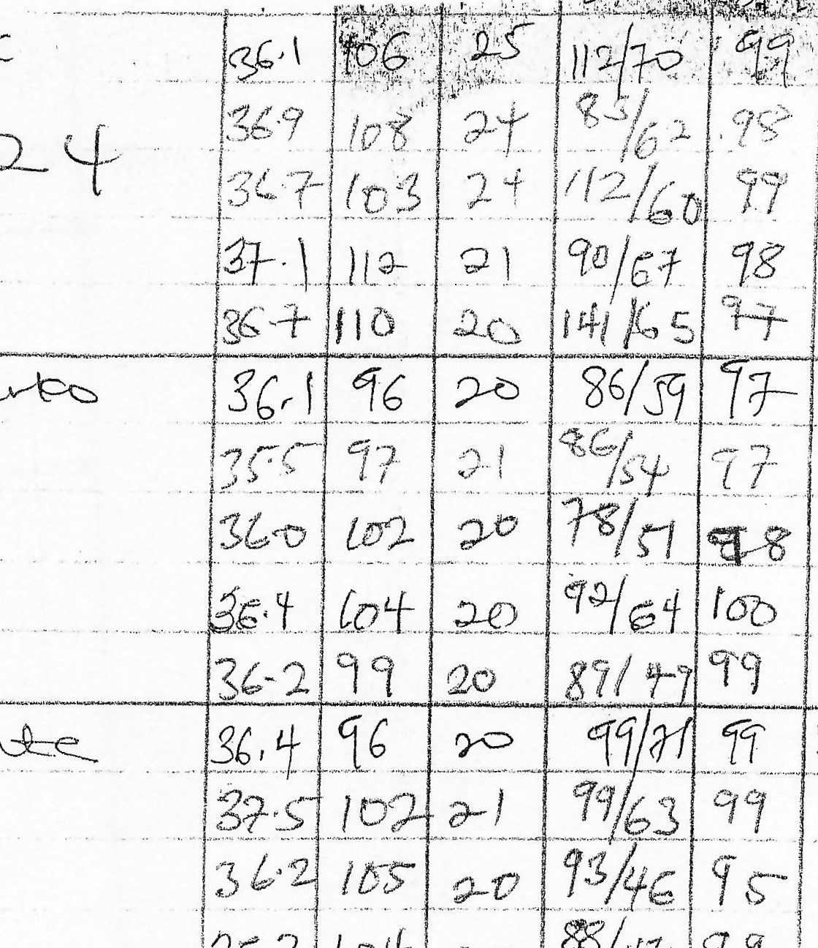
年 い物廿ミ二~、ル ィーZてれ、′
ラ
2
を
3
地
十
)
ラ
ク
チ
・
9
7
)

鰲単をを霧毳攣齡} 確ま
~
2
・ ~ 〔郊 3、
~ 和
。一ミ〈まをを、
、、」番帋ル駑一障器擘
- ま緝、兢当
3 3蠡毬こ
・旅
!
甲、
、蔀な盛
、お
羲融
~韲
(
、蘢。
、
"
、を
い
一
い物
( 一
明鼾
、
「
髴
「
ま
. 整
一
ず
?F.; | .
い 1-  い | 韆
・  。な  いな  ( ( い当  → | ミご当
寿
」こ曜
3 いト
ーー
照年
づ裳
(
翹な
、名
1
、
・
心
一当
オルー鑒イ
3乙そ3 2イ〃乞0 /
。4

3い/
3をまこっ
3こな2應
97
19
9 1
9ナ青 1冒气1
=
了
3に一・
チ7サ調ⅱ名
コ0 に 電
レ0 ユ。.。,亂0 /こ0 当多0。に一= ~な。
奚ら(新一呷6。

, 5し9-S
ス斗0名し,プ。い騫んし
」ミ「い勹
[ちユ0 2
、0,Sル、(当
0 ュ 3 0 0
岳
一
誉
一
、囂
す
をを下
:
斗顰
【ヾ
学
当 :
、、
寿
一朝
' ヾ
ー
づま
ら | に
~ ,-尾(l /毎
に ー 、一。こ気3を。1・リ& 18みまァ年。,
区0はぐ7チ
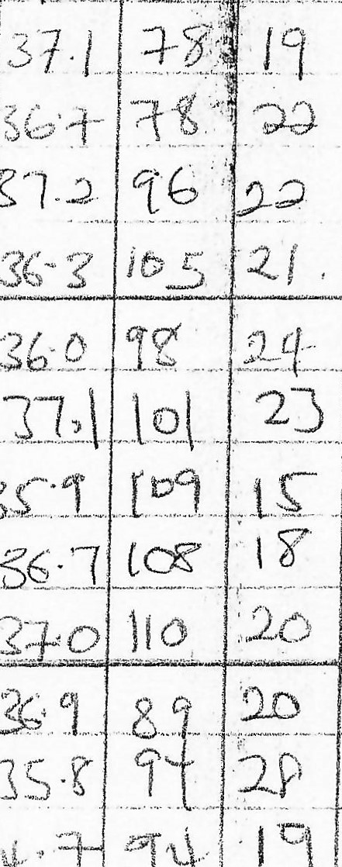
っ0。に1 ~、ヒ- =て一上
冂
ー
こ
ン
.
い
,
~
代
。
卩
,
、
0
朝
師
つ
し
午
,
、
,
要
い
=
し
,
つ
ぞ
(
/
、
気
。
ん
ⅵ
られに。子躪 0朝砧1乙
国 トに 7ユ ⅱ引629

翡名D孵ら
, ,、,。7っ25まⅡ曰(3
【  、ら診  " を乙ー  、 | を3乙1コっ乙[区/ー气フ
鵞ミ | にみ:な 20 に 扉) 70

し、新い
・
霻
づ"0」」を ーイ、,、「社守て 効区0ュ
蓍:
、
( ミを
確〒 に冫を震0い.※は爻。ぎ、~,ュ、、い, gB凵ロⅵ色-ロお
嬲1つユ者/匀ィ,る75岼子
当いし
, を母彎
一な
'
》、も
、 ャ觜な
〕 -
蛍当 物ツ物い・
・・
ー弖三・ら 置い 二ない!、物
:、をミこい、3込ツ
響ミは嚀」、=囈噫な3な、
こ津い
!事
,川

丶

•2
1
-S

